

**N ASCOP**

**Government of Kenya**

**Ministry of Health**

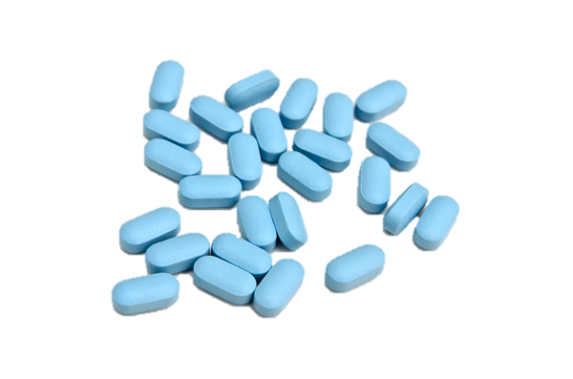

**Facility Pre-Exposure Prophylaxis (PrEP) Assessment in Kenya**

**FACILITY PRE-EXPOSURE PROPHYLAXIS (PrEP) ASSESSMENT IN KENYA**



**© National AIDS & STI Control Program 2018**

All rights reserved. No part of this publication may be reproduced, distributed, or transmitted in any form or by any means, including photocopying or recording, without the prior written permission of the Ministry of Health through the National AIDS and STI Control Programme (NASCOP), Ministry of Health Kenya except in the case of brief quotations in critical reviews and certain other non-commercial uses permitted by copyright law.

This document that contains relevant information on the uptake of Pre-Exposure Prophylaxis (PrEP) in 34 counties in Kenya as at February 2018. All reasonable precautions have been taken by NASCOP to verify the information contained in this document.

For Clarifications and enquiries please contact:- The National AIDS and STI Control Programme (NASCOP), P.O Box 19361 Nairobi, Kenya on Tel: 254202729502, 2714972 or Email: info@nascop.or.ke

**Recommended citation for this Assessment is as follows:**

**Design and layout:**



PREFACE

In 2015, the World Health Organisation (WHO) recommended the use of Pre-Exposure Prophylaxis (PrEP) as an Antiretroviral Therapy (ART) to prevent and reduce the risk of contracting Human Immunodeficiency Virus (HIV) for populations that are at a high ongoing risk of contracting HIV infection. Today, in the world over, including Kenya, PrEP has been recognized as an added prevention mechanism that can be used as part of a tailor-made combination of prevention methods for the specific targeted populations.

In Kenya, positive strides have been made to ensure that PrEP knowledge is readily available and accessible to health workers for dissemination to the targeted populations across the country. MoH has incorporated in the national policies and guidelines related to HIV, the implementation, management and administration of PrEP based on recent evidence that daily oral PrEP intake significantly reduces the chances of HIV infection. These include:- the Kenyan HIV Prevention Revolution Roadmap, the most recent Kenya AIDS Strategic Framework (KASF) and the Guidelines on use of ARV drugs for treating and preventing HIV infections in Kenya – 2016 edition. Most recently a framework for the implementation of PrEP and a PrEP toolkit were developed to equip the relevant stakeholders with the requisite knowledge on PrEP administration.

This assessment was therefore informed by the need to understand the progress that has been made with regards to PrEP implementation since its inception and official launch in May 2017 in Kenya. It further sought to identify the gaps and areas that required urgent action.

I am confident that the findings and recommendations that have been documented in this report will inform key decisions on policy changes that require to be made in Kenya to ensure that the gaps are addressed leading to a scale up in the uptake of PrEP hence realizing its full potential. This would in turn ensure that there are zero new HIV infections in Kenya.

**Dr. Jackson Kioko**

**Director of Medical Services**

**Ministry of Health**



ACKNOWLEDGEMENTS

The PrEP assessment was conducted in 852 facilities across 34 counties in Kenya. The process of the assessment involved data collection, data clean up, data analysis and documentation of findings. Led by the Ministry of Health through NASCOP, this report was developed through the continued unwavering support and contributions of various stakeholders who worked tirelessly in ensuring the successful completion. I am therefore cognizant of the fact that without these stakeholder’s commitment, documentation of this report would not have borne any fruits.

I wish to recognize the partner, Clinton Health Access Initiative (CHAI) for their technical and financial support, without whom the process would not have taken place. I am grateful for the support and guidance that was offered to the field teams by the County Government through the County AIDS and STI Coordinators (CASCO) and Sub-County AIDS and STI Coordinators (SCASCO) who were engaged in the data collection process and ensured that it was seamless across the 34 counties. I also appreciate the effort and the time taken by the management and staff of the concerned 852 facilities to provide us with the requisite information.

Finally, my special and sincere appreciation goes to the team that regularly reviewed and provided technical input towards completion of the assessment report through the oversight and guidance provided by Dr. Irene Mukui. They are: NASCOP: Dr Maureen Kimani, Dr. Violet Oramisi, Precious Otieno, Joel Mutinda. CHAI: Jackson Hungu, Davis Karambi, Justus Ogando, Philip Kimani, Victoria Wanjohi,

**Dr Kigen B Bartilol**

**Head, National AIDS and STI Control Program (NASCOP)**

**Ministry of Health**



TABLE OF CONTENTS

PAGE

PREFACE 3

ACKNOWLEDGEMENTS 4

TABLE OF CONTENTS 5

LIST OF TABLES 9

LIST OF FIGURES 10

ABBREVIATIONS 12

EXECUTIVE SUMMARY 14

1. INTRODUCTION 15

1.1 Rationale 16

1.2 Objectives 16

2. METHODOLOGY 18

2.1 Data collection 19

2.2 Timeframe 19

2.3 Data analysis process 19

2.4 Capacity building 19

2.5 Challenges/ limitations 20

3. FACILITY PrEP ASSESSMENT FINDINGS 21

3.1 Facility demographics 21

3.1.1 Facilities assessed by county 21

3.1.2 Facilities assessed by level 22

3.1.3 Facility ownership 23

3.1.4 Distribution of facilities assessed nationally 24

3.1.5 Distribution of PrEP clients by nationally 25

3.2 Service delivery 26

3.2.3 PrEP focal person 26

3.2.4 Implementing partner support 26

3.2.3 Availability of HIV services 28

3.2.4 Duration of PrEP provision in facilities 29

3.2.5 PrEP availability by facility level 29

3.2.6 Service delivery points for PrEP in the facilities 30

3.2.7 Population receiving PrEP in facilities 32

3.3 Laboratory Services 33

3.3.2 Creatinine Testing 33

3.3.3 Hepatitis B Testing 37

3.3.4 Hepatitis C Testing 39

3.4 Human Resources 43

3.4.1 Proportion of facilities with trained personnel 43

3.4.2 Trained personnel by facility and county 44

3.4.3 Type of training 45

3.4.4 Distribution of cadres trained on PrEP 45

3.4.5 Location of trained personnel 46

3.4.6 Proportion of each cadre offering PrEP 46

3.4.7 Trained personnel vs those offering PrEP 46

3.5 Commodity Management 47

3.5.1 PrEP facilities offering ART 47

3.5.2 Source of ARV’s in facilities 47

3.5.3 Dispensing points for PrEP 48

3.5.4 Proportion of stock levels in facilities 50

3.5.5 PrEP regimens dispensed 50

3.5.6 Cadres dispensing PrEP 51

3.5.7 Type of PrEP dispensing software 53

3.5.8 Proportion of dispensing staff trained on various trainings 54

3.6 Monitoring and Evaluation – change graphs 55

3.6.1 LMIS tools 55

3.6.2 Clinical encounter forms 56

3.6.3 Pharmacovigilance tools 57

3.6.4 PrEP register 58

3.6.5 Rapid assessment screening tool 59

3.6.6 PrEP summary tool 59

3.6.7 Clients ever started on PrEP 60

3.6.8 Clients currently on PrEP and active 61

3.6.9 Proportion of facilities using EMR’s 62

3.7 Communication and Advocacy 63

3.7.1 Availability of IEC materials 63

3.7.2 Availability of activities about PrEP education 64

3.7.3 Availability of demand creation 65

3.7.4 Availability of data 65

4. PATIENT SPECIFIC INFORMATION FROM FILES ASSESSED 66

4.1 Gender and age distribution 66

4.2 Current status – LTFU, Active, Unknown, Not Documented 67

4.3 Duration on PrEP 67

4.4 Laboratory tests conducted 68

4.5 Eligibility 70

4.5 Client follow up mechanism 70

5. CONCLUSIONS 72

6. RECOMMENDATIONS 74

6.1 Framework and guidelines 74

6.2 Coordination 74

6.3 Resources 74

6.4 Research 74

7. ANNEXURES 75

8. REFERENCES 76



LIST OF TABLES

Table 1 : Distribution of facilities by level 22

Table 2: Areas supported by partners in the PrEP offering facilities 27

Table 3: Availability of HIV services in facilities 29

Table 4: Duration of PrEP provision across facilities 29

Table 5: Distribution of PrEP offering facilities by level 30

Table 6: Distribution of service delivery points 30

Table 7: Distribution of preferred service delivery points 32

Table 8: Key populations targeted for PrEP 32

Table 9: Overall access to laboratory testing, availability of equipment and access to on- site and offsite testing 33

Table 10: Onsite and offsite testing for facilities with access to creatinine testing 35

Table 11: Access to creatinine testing in relation to equipment availability 36

Table 12: Creatinine equipment vs reagents 36

Table 13: On site vs offsite testing for facilities with access to Hepatitis B testing 38

Table 14: Access to Hep B testing in relation to equipment availability 39

Table 15: Hep B equipment vs reagents 39

Table 16: On site vs off site testing for Facilities with access to Hepatitis C Testing 41

Table 17: Access to Hep C testing versus equipment 41

Table 18: Availability of Hep C equipment versus reagents 42

Table 19: Health Care Workers trained for 1-3, 3-6 and >6 44

Table 20: Type of training received 45

Table 21: PrEP dispensing points for facilities assessed 49

Table 22: Stock levels in facilities 50

Table 23: PrEP regimens dispensed at facilities assessed 50

Table 24: PrEP dispensing software used 53

Table 25: Overall availability of PrEP M & E tools 55

Table 26: Availability of EMR’s for client records 62

Table 27: Availability of communication and advocacy mechanisms 63

Table 28: Age distribution of PrEP patients from patient files assessed 67

Table 29: Current status of PrEP patients 67

Table 30: Patient files showing creatinine, Hep B and Hep C testing records 68

Table 31: Eligibility recording in client files assessed 70

Table 32: Client follow up mechanisms in the facilities 71



LIST OF FIGURES

Figure 1: Process of data collection and analysis 18

Figure 2: Facility assessed distribution by county 22

Figure 3: Distribution of facilities by level per county 23

Figure 4: Ownership of facilities assessed 24

Figure 5: Distribution of Prep offering health facilities 24

Figure 6: Distribution of PrEP clients by County 25

Figure 7: PrEP focal person in facilities by county 26

Figure 8: Availability of partner support within facilities by county 27

Figure 9: Distribution of HIV services in facilities assessed nationally 28

Figure 10: Distribution of service delivery points by county 31

Figure 11: Access to creatinine testing in facilities by county 34

Figure 12: Proportion of facilities that carry out creatinine testing onsite vs offsite 34

Figure 13: Availability of creatinine testing equipment by county 35

Figure 14: Facilities with access to creatinine testing in relation to availability of equipment 36

Figure 15: Access to Hepatitis B testing in facilities by county 37

Figure 16: Proportion of facilities that carry out Hepatitis B testing onsite vs offsite 37

Figure 17: Availability of Hepatitis B testing equipment by county 38

Figure 18: Facilities with access to Hep B testing in relation to availability of equipment 39

Figure 19: Access to Hepatitis C testing in facilities by county 40

Figure 20: Proportion of facilities that carry out Hepatitis B testing onsite vs offsite 40

Figure 21: Availability of Hepatitis C testing equipment in facilities by county 41

Figure 22: Facilities with access to creatinine testing in relation to availability of equipment 42

Figure 23: Proportion of trained vs untrained health care workers 43

Figure 24: Distribution of trained personnel in facilities by county 44

Figure 25: Distribution of trained personnel by numbers in facilities by county 45

Figure 26: Distribution of cadre trained on PrEP 46

Figure 27: Source of ARVs in facilities assessed 47

Figure 28: Facility source of ARVs by county 48

Figure 29: PrEP dispensing points in facilities by county 49

Figure 30: PrEP regimen in facilities by county 51

Figure 31: Cadres dispensing PrEP at the facilities 52

Figure 32: Distribution of cadres dispensing PrEP in facilities by county 52

Figure 33: PrEP dispensing software in facilities by county 54

Figure 34: Availability of LMIS tools in facilities by county 56

Figure 35: Availability of clinical encounter form in facilities by county 57

Figure 36: Availability of pharmacovigilance tools in facilities by county 58

Figure 37: Availability of PrEP register in facilities by county 59

Figure 38: Availability of PrEP summary tool in facilities by county 60

Figure 39: Clients started and active on PrEP 60

Figure 40: Clients currently on PrEP 61

Figure 41: Availability of PrEP IEC materials in facilities by county 64

Figure 42: Availability of activities about PrEP education in facilities by county 64

Figure 43: Availability of demand creation activities in facilities by county 65

Figure 44: Number of clients by duration on PrEP 68

Figure 45: Creatinine testing in the facilities by county 69

Figure 46: Hepatitis B testing in facilities by county 69

Figure 47: Hepatitis C testing in facilities by county 70

Figure 48: Recommendations to scale up PrEP in Kenya 74



ABBREVIATIONS

ADR Adverse Drug Reaction

AGYW Adolescent Girls and Young Women

ART Antiretroviral Therapy

ARVS Antiretroviral Drug(s)

CASCO County AIDS and STI Coordinator

CCC Comprehensive Care Centre

CHAI Clinton Health Access Initiative

CrCL Creatinine Clearance

DICEs Drop In Centers

EMR Electronic Medical Records

FDA Food and Drug Administration

FDC Fixed Dose Combination

FSWs Female Sex Workers

FTC Emtricitabine

HBsAg Hepatitis B Surface Antigen

HCV Hepatitis C Virus

HIV Human Immunodeficiency Virus

IEC Information Education and Communication

IPD In Patient Department

KEMSA Kenya Medical Supplies Agency

KP Key Population

LMIS Logistics Management Information System

LTFU Lost To Follow Up

M&E Monitoring and Evaluation

MoH Ministry of Health

MSM Men Who Have Sex with Men

NASCOP National AIDS and STI Control Program

OPD Out Patient Department

PEP Post Exposure Prophylaxis

PMTCT Prevention of Mother to Child Transmission

PrEP Pre-Exposure Prophylaxis

PWID People Who Inject Drugs

STIs Sexually Transmitted Infections

SCASCO Sub-County AIDS and STI Coordinator

TDF Tenofovir Disoproxil Fumarate



EXECUTIVE SUMMARY

Today, PrEP represents a significant new addition to the HIV prevention strategies which include HIV Testing Services, Risk reduction counselling, Voluntary Medical Male Circumcision, Condoms and Elimination of Mother to Child Transmission (4). However, its full potential to reduce the HIV epidemic is yet to be realized as its uptake and acceptability has remained relatively slow and low. As PrEP is a relatively new HIV prevention measure in Kenya, very little is known about its acceptability and adherence to the documented regimen. Furthermore, monitoring and evaluation data on PrEP in Kenya is in some cases very limited or non-existent.

This assessment sought to establish the knowledge, attitudes and beliefs that ultimately influence decisions to endorse and disseminate PrEP to the communities in Kenya. Key areas that were assessed were considered to have an impact on the implementation, management and administration of PrEP..

The key findings from the PrEP assessment were grouped into six (6) key themes as outlined:-

**How will these findings be applied**

# INTRODUCTION

In the last decade, HIV prevention experienced a distinct shift, with emphasis on biomedical strategies to supplement behavioral interventions. One of these approaches is the use of pre exposure prophylaxis (PrEP) which is an additional form of HIV prevention offered as part of combination HIV prevention approaches for HIV negative people at substantial ongoing risk of HIV infection. Several countries have developed guidelines for implementation of PrEP and are currently offering PrEP. PrEP provides an important public health opportunity to substantially decrease HIV incidence. In Kenya, there has been significant progress made in reducing the HIV epidemic and HIV prevalence; the country has dropped by nearly 50% from a peak of 10.6% in 1995/96 to approximately 5.6% in 2017. Prevalence of HIV has reduced due to aggressive implementation of a combination of evidence-based interventions including scale-up of antiretroviral where therapy. However, there has been little decline in new infections (incidence) with nearly 71,000 new infections occurring every year and this is where if used effectively, PrEP reduce the number of new HIV infections. Recent evidence has shown that daily oral antiretroviral drugs, taken by HIV uninfected individuals at substantial ongoing risk of HIV infection, can significantly reduce the chances of HIV infection. Based on this evidence, the Ministry of Health reviewed the HIV treatment guidelines to incorporate guidance on PrEP for the prevention of HIV infection in Kenya in the year 2016.

Some of the populations that have been identified to benefit from PrEP include: HIV serodiscordant couples where the HIV infected partner has not been on effective (suppressive) therapy for the preceding 6 months, HIV serodiscordant couples trying to conceive, pregnant or breastfeeding women whose sex partners are HIV positive or at high risk of HIV infection, sexual partner/s of unknown HIV status and is/are at high-risk for HIV infection (has multiple sexual partners, has had STIs, engages in transactional sex, injects drugs, or from high HIV burden settings), engaging in transactional sex, recent sexually transmitted infection, recurrent use of post-exposure prophylaxis, history of sex whilst under the influence of alcohol or recreational drugs as a habit, inconsistent or no condom use or inability to negotiate condom use during intercourse with persons of unknown HIV status and injection drug use where injection equipment is shared. Contraindications to PrEP use include HIV infection (confirmed HIV positive), renal impairment (creatinine clearance < 50 ml/min), lack of willingness to adherence to daily use of PrEP and associated follow-up schedule and adolescents weighing < 35kgs or age < 15 years.

Further, while PrEP acceptability and adoption is growing since its FDA approval in 2012, uptake has not kept pace with expectations despite clinical practice guidelines supporting its use. To maximize its prevention potential, the public health impact of PrEP requires a two-pronged approach that will lead to: 1) large-scale adoption among eligible populations and 2) identification of current gaps in knowledge and prescription behaviors among health care providers. There is an urgent need to understand PrEP knowledge, attitudes, and beliefs that may ultimately influence decisions to endorse and disseminate PrEP for both individual and public health benefits.

# Rationale

Pre-exposure prophylaxis represents a significant potential new addition to the HIV prevention strategies; however, its full potential to reduce the HIV epidemic has yet to be realized because its uptake and acceptability has been slow. We need to better understand factors influencing PrEP uptake and behavior that might determine actual effectiveness. As a country since the launch of PrEP as a new prevention measure, little was known about its acceptability and client adherence to the regimen and we also had limited data on PrEP uptake. We therefore set out to conduct an PrEP facility assessment of all health facilities reported to be providing PrEP in 34 Counties as per our database to establish readiness and capacity to provide PrEP services, availability of M and E tools and gaps in provision of PrEP. The results of the assessment would form basis for the national and county governments, implementing partners and other stakeholders to rationalize PrEP services and inform on PrEP uptake.

# Objectives

The objective of the assessment was to assess readiness and availability of PrEP services in facilities that are currently reported to be providing PrEP in Kenya as at Feb 2018. Some of the specific objectives were;

• To assess the availability of PrEP trained personnel in facilities providing PrEP in Kenya.

• To assess the availability of supporting service (lab services and commodities) in facilities providing PrEP in Kenya

• To assess availability and use of M and E tools in facilities providing PrEP in Kenya.

• To identify the challenges facing implementation of PrEP in health facilities in Kenya

# METHODOLOGY

This section describes the methodology that facilitated the smooth collection of data in the 852 located in 34 counties. The 852 facilities that reported to be providing PrEP were identified during the partner mapping exercise carried out prior to commencement of the assessment. The counties were Baringo, Bomet, Bungoma, Busia, Homabay, Kajiado, Kakamega, Kericho, Kiambu, Kilifi, Kirinyaga, Kisii, Kisumu, Kitui, Kwale, Laikipia, Machakos, Makueni, Marsabit, Migori, Mombasa, Muranga, Nairobi, Nakuru, Nandi, Narok, Nyeri, Samburu, Siaya, Taita Taveta, Trans Nzoia, Turkana, Uasin Gishu and Vihiga.

The **figure 1** outlines the process of the PrEP mobilisation, implementation, data analysis and reporting.

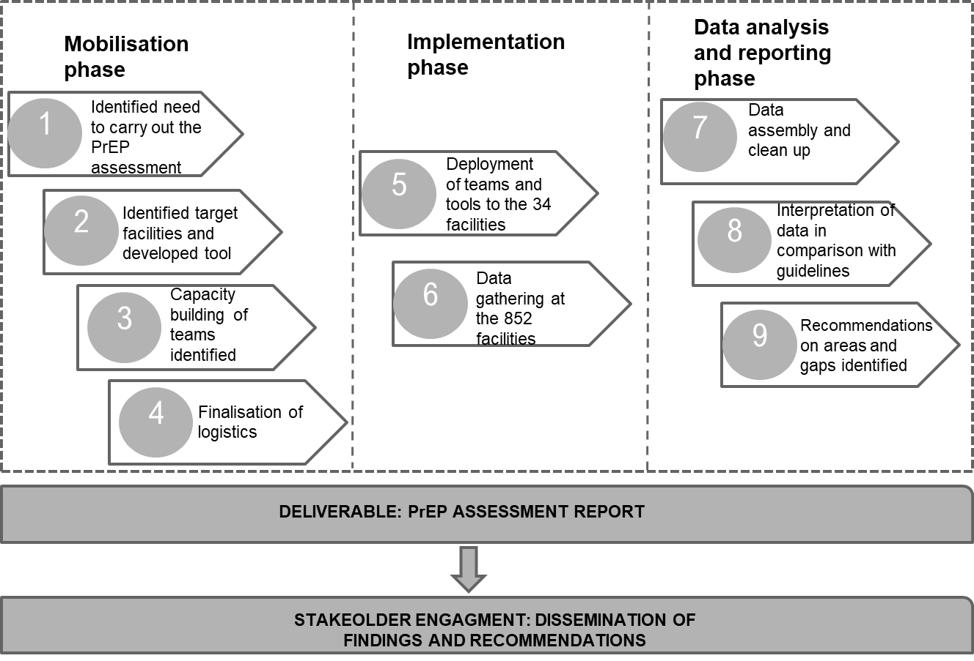

Figure 1: Process of data collection and analysis

# Data collection

A cross sectional study design was adopted and census of all health facilities that offered PrEP services in all the 34 counties.

Data collection was carried out using a GPS enabled electronic tool which was organized into sections on service delivery, human resources, commodity management, monitoring and evaluation, communication and advocacy and general gaps in service delivery. The tool had a mix of both qualitative and quantitative questions for assessment.

The data collection team comprised of individuals from the National Program (NASCOP) County Government (CASCO and SCASCO) and the partner (CHAI).

# Timeframe

The assessment was undertaken in the month of March 2018 for a period of one (1) month across 34 counties in Kenya. However, data as at February 2018 was used to carry out this assessment in facilities.

# Data analysis process

Data cleaning was conducted for the data collected to ensure that the right data sets were being analyzed and to remove any inconsistent or inaccurate entries. The data was then split into different themes to ensure a seamless data analysis process.

The quantitative analysis was carried out using TableauDesktop-64 bit-10-5-1, Epi INFO and Microsoft excel while the qualitative analysis was carried through the review of the feedback questionnaires distributed to each facility and the responses organized according to emerging themes.

# Capacity building

The National, County and Sub-county data teams were trained to ensure familiarity with the electronic tool. Knowledge transfer was a key component for the PrEP assessment to be successful as it ensured fostered commitment to the rationale and the key objectives. Frequent meetings to discuss the day to day outcomes in the field and facilitate pre-briefs and debriefs were also key for successful data collection from the facilities.

A key milestone for this assessment was that accurate data be collected therefore capacity building was an imperative measure.

# Challenges/ limitations

Some of the challenges encountered whilst collecting data for the PrEP assessment were: lack of readily available data at facilities, unpreparedness of the respondents and the facilities, increased scope that is: the number of facilities to be assessed in some of the counties increased as more were found to be offering PrEP after discussions with the CASCO’s and SCASCO’s. Given that the team had to cover a number of facilities within a day, the time taken in some facilities was more than was intended. Some of the facilities assumed to be providing PrEP during the partner mapping exercise prior to commencement of the assessment were found not to be providing PrEP. The assessment was only carried out in the facilities therefore the perspective of the communities was not taken into account.

# FACILITY PrEP ASSESSMENT FINDINGS

This section outlines the demographic characteristics of the PrEP offering facilities assessed and further describes the findings derived from the analysis of the data collected. The findings from the primary data collected from the 852 facilities as at February 2018 are further compared with the PrEP documented guidelines to be able to assess for compliance to standards. The findings have been documented based on the six (6) key themes: -

* Service delivery
* Laboratory services
* Human resources
* Commodity Management
* Monitoring and Evaluation
* Communication and advocacy

# Facility demographics

The overall description of the facilities assessed is as outlined.

# Facilities assessed by county

A total of 852 facilities were assessed of which 807 (94.7%) were found to offer PrEP related services. Siaya County had the most facilities 139 (16.3%) followed by Kisumu 99 (11.6%), Homabay 88 (10.3%) and Nairobi 68 (7.9%). Trans- Nzoia and Samburu counties each had one (1) facility. From the analysis it was noted that counties considered to have high HIV prevalence had majority of the facilities offering PrEP and the vice versa for the counties with low HIV prevalence.

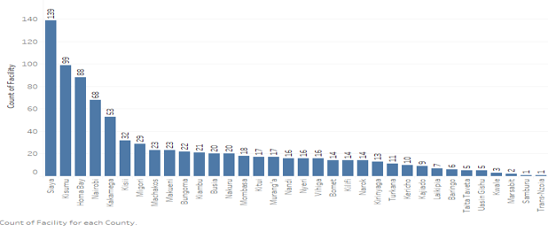

Figure 2: Facility assessed distribution by county

# Facilities assessed by level

The various levels of the 852 facilities assessed were analysed as illustrated in figure XX, health centres were 270 (31.7%), dispensaries 187 (21.9%) and sub-county hospitals 156 (18.3%). National Referral hospitals had the least number of facilities assessed 2 (0.2%). Other facilities that did not have a level were either mission hospitals or private facilities which were a total of 139 (16.3%) facilities.

|  |  |  |
| --- | --- | --- |
| **Level** | **Frequency** | **Percent** |
| **Health Centers** | 270 | 31.7% |
| **Dispensary** | 187 | 21.9% |
| **Sub County Hospital** | 156 | 18.3% |
| **Others** | 139 | 16.3% |
| **DICE** | 50 | 5.9% |
| **County Referral Hospital** | 34 | 4.0% |
| **County Hospital** | 14 | 1.6% |
| **National Referral Hospital** | 2 | 0.2% |
| **Total** | **852** | **100.0%** |

Table 1 : Distribution of facilities by level

A further analysis of the distribution of facilities by level per county is illustrated in figure XX. Siaya county had a majority of the health centres 72 (26.7%) and dispensaries 36 (19.2%) while four (4) counties: Marsabit, Trans Nzoia, Turkana and Uasin Gishu counties did not have any health centres and dispensaries. The two (2) national referral facilities were in Nairobi and Uasin Gishu counties only. It was further established that majority of the DICES 14 (28.0%) were in Nairobi county.

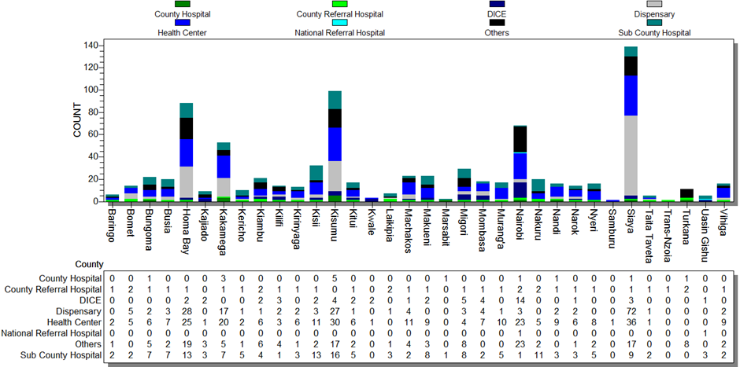

Figure 3: Distribution of facilities by level per county

# Facility ownership

The 852 facilities assessed were owned by different stakeholders as illustrated in **figure 7.** Themajority 640 (75.1%) were Government (public) owned facilities. The rest of the facilities, 92 (10.8%) were owned by Faith Based organization’s (FBO’s), 78 (9.2%) were owned by Non-Governmental Organizations (NGO’s) and 42 (4.9%) were privately owned.

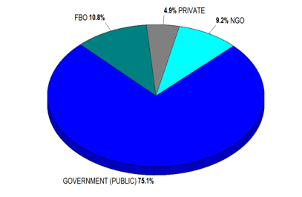

Figure 4: Ownership of facilities assessed

# Distribution of facilities assessed nationally

The map in figure XX illustrates the distribution of facilities by county. Siaya county had more than 100 PrEP offering facilities. It is worth noting that although Siaya county had the highest number of facilities (139), the number of PrEP clients were 1,452. Kisumu and Nairobi counties had the highest number of PrEP clients with only 99 and 68 PrEP offering facilities respectively. The map further indicates that in the counties were there were no PrEP clients similarly, there were no PrEP facilities. Trans-Nzoia and Samburu counties each had only one (1) PrEP offering facility.

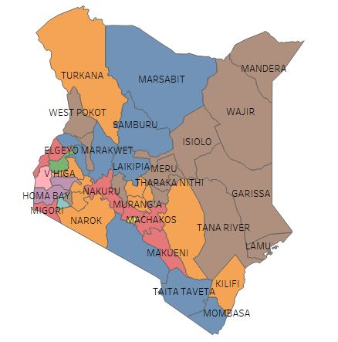 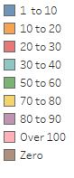

Figure 5: Distribution of Prep offering health facilities

# Distribution of PrEP clients by nationally

The figure xx shows a map outlining distribution of PrEP clients across the 34 counties in Kenya. Nairobi and Kisumu counties had the highest number of clients on PrEP, 5,445 and 4,880 respectively. The map further outlines the counties whereby the PrEP assessment was not carried out as there were no PrEP clients. From the map it is also evident that majority of the counties had less than 100 PrEP clients.

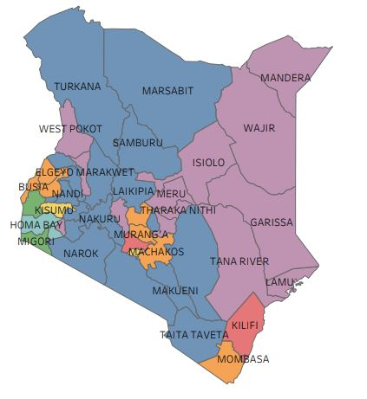 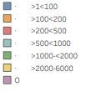

Figure 6: Distribution of PrEP clients by County

# Service delivery

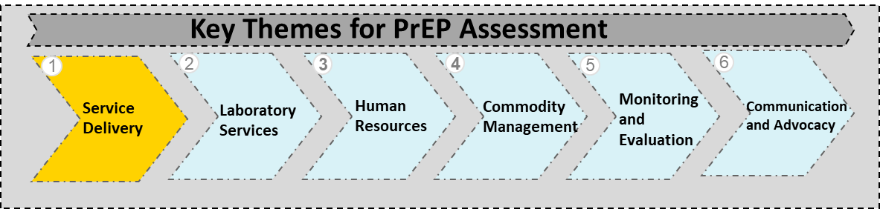.

This section outlines findings from the facilities which include the availability of a focal person for PrEP, partner support and footprint, availability of HIV services in the facilities, availability, provision and duration of PrEP services , service provision points as well as target population and current recipients of PrEP.

# PrEP focal person

Of the 852 facilities assessed, the majority 86.4 % (736) had a PrEP focal person. The by county analysis in figure XX illustrates that all the facilities in seven (7) counties: Kirinyaga, Laikipia, Machakos, Marsabit, Nyeri, Samburu and Vihiga had a PrEP focal person. Trans-Nzoia county was the only county whereby no focal person was available in the facility.

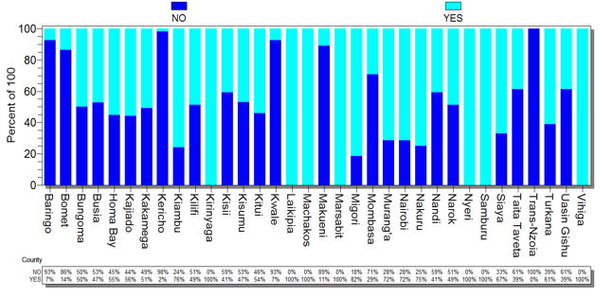

Figure 7: PrEP focal person in facilities by county

# Implementing partner support

Partner footprint in facilities offering PrEP is important as they offer support in various areas to aid in the implementation of PrEP. Partners facilitate support through laboratory services, resource mobilization, capacity building, support in service delivery amongst many other areas. Overally, of the 852 facilities assessed, 765 (89.9%) were supported by partners. From the county analysis 11 counties: Kakamega, Kirinyaga, Kwale, Migori, Nandi, Narok, Samburu, Trans-Nzoia, Turkana, Uasin Gishu and Vihiga had all the facilities supported by implementing partners and two (2) counties: Kericho and Marsabit had no implementing partner support in the facilities assessed.

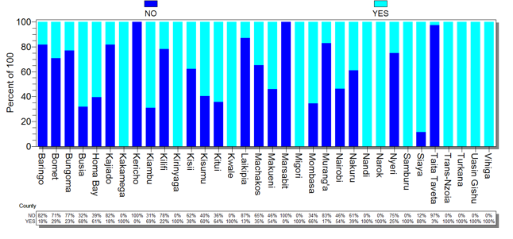

Figure 8: Availability of partner support within facilities by county

Majority of the facilities 641 (83.8%) were supported by partners on the M & E component, 569 (74.4%) facilities were supported in hiring of staff and 521 (68.1%) facilities were supported in the provision of IEC materials. It was further noted that partners supported 79 (10.3%) facilities in other areas, these were capacity building, Continuing Medical Education (CME’s), mentorship, transport allowance and advocacy amongst others.

|  |  |  |
| --- | --- | --- |
| **Support Provided** | **No. of Facilities** | **Percent** |
| **M&E tools** | 641 | 83.8% |
| **Hiring Staff** | 569 | 74.4% |
| **IEC Materials** | 521 | 68.1% |
| **Provision of equipment and Furniture** | 467 | 61.1% |
| **Lab Support** | 385 | 50.3% |
| **Other** | 79 | 10.3% |

Table 2: Areas supported by partners in the PrEP offering facilities

# Partner footprint in counties

# Availability of HIV services

The distribution of HIV services offered in the 852 facilities assessed is as outlined in figure XX. HTS were the majority of services being provided in 822 (96.5%) facilities. This was closely followed by PrEP 807 (94.7%) and ART 801 (94.0%). Other HIV related services offered in 42 (4.9%) of the facilities were family planning, distribution of condoms, STI screening, cervical cancer screening, nutrition and gender based violence.

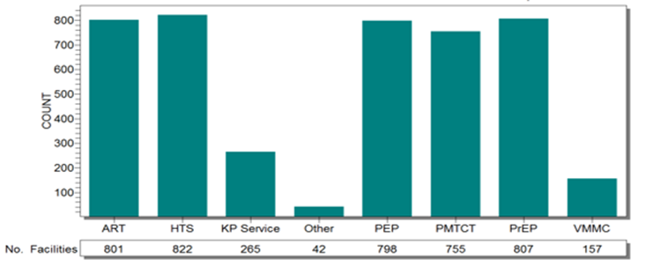

Figure 9: Distribution of HIV services in facilities assessed nationally

In the 852 facilities assessed, HIV services offered in the various levels of the 852 facilities assessed with health centres and dispensaries levels having a majority of the facilities (table XX)

|  |  |  |  |  |  |  |  |  |
| --- | --- | --- | --- | --- | --- | --- | --- | --- |
| **Level** | **ART** | **HTS** | **KP Service** | **Other** | **PEP** | **PMTCT** | **PrEP** | **VMMC** |
| **Health Center** | 302 | 311 | 103 | 16 | 300 | 278 | 302 | 61 |
| **Dispensary** | 211 | 215 | 68 | 9 | 209 | 204 | 212 | 50 |
| **Sub County Hospital** | 142 | 147 | 45 | 6 | 143 | 141 | 146 | 29 |
|  |  |  |  |  |  |  |  |  |
| **DICE** | 48 | 49 | 18 | 1 | 48 | 41 | 48 | 7 |
| **Other (specify)** | 45 | 46 | 17 | 3 | 45 | 40 | 45 | 4 |
| **County Referral Hospital** | 33 | 34 | 7 | 6 | 33 | 33 | 34 | 4 |
| **County Hospital** | 17 | 17 | 5 | 1 | 17 | 15 | 17 | 2 |
| **National Referral Hospital** | 3 | 3 | 2 | 0 | 3 | 3 | 3 | 0 |
| **TOTAL** | 801 | 822 | 265 | 42 | 798 | 755 | 807 | 157 |
| **% Distribution** | **94** | **96.5** | **31.1** | **4.9** | **93.7** | **88.6** | **94.7** | **18.4** |

Table 3: Availability of HIV services in facilities

# Duration of PrEP provision in facilities

The provision of PrEP in Kenya was officially launched in May 2017. However, prior to this some facilities had been earmarked as PrEP demo projects which commenced in 2012. The table XX indicates that of 785 facilities that responded PrEP offering facilities have gradually increased over the last three (2) years. The number of facilities that started offering PrEP after the official launch were the majority 659 (83.9%).

|  |  |  |  |
| --- | --- | --- | --- |
| **Description** | **Duration** | **Frequency** | **Percent** |
| **Post PrEP Launch** | May 2017 - Feb 2018 | 659 | 83.9% |
| **Launch of ART guidelines that included PrEP** | July 2016 - April 2017 | 122 | 15.5% |
| **Demonstration projects** | 2012-June 2016 | 4 | 0.5% |
| **Total** | | **785** | **100.0%** |

Table 4: Duration of PrEP provision across facilities

# PrEP availability by facility level

The total number of facilities assessed were 852, of which 807 were found to be providing PrEP. The table XX illustrates the distribution of availability of PrEP by facility by level.

|  |  |  |
| --- | --- | --- |
| **Level** | **Frequency** | **Percent** |
| **Health Center** | 302 | 37.4% |
| **Dispensary** | 212 | 26.3% |
| **Sub County Hospital** | 146 | 18.1% |
| **DICE** | 48 | 5.9% |
| **Other (specify)** | 45 | 5.6% |
| **County Referral Hospital** | 34 | 4.2% |
| **County Hospital** | 17 | 2.1% |
| **National Referral Hospital** | 3 | 0.4% |
| **Total** | **807** | **100.0%** |

Table 5: Distribution of PrEP offering facilities by level

# Service delivery points for PrEP in the facilities

PrEP services were offered to clients at different Service Delivery Points (SDP’s) located within the facilities. The SDP in use is usually dependent on the service of delivery model and the target population of the facility. Across the 852 facilities the table XX shows that there were a total eight (8) key SDP’s of which the frequency of distribution was 1,147. Comprehensive Care Centres (CCC’s) were the majority 691 (60.2%). This was followed by the Prevention of Mother to Child Transmission (PMTCT) clinics 135 (11.8%). In Patient Department (IPD) were the least with a total of 5 (0.4%). Other SDP’s were safe spaces, outreach sites, key population sites, pharmacies and VCT.

|  |  |  |
| --- | --- | --- |
| **Current SDP by facilities** | **Frequency** | **Percent** |
| **CCC** | 691 | 60.2% |
| **PMTCT Clinic** | 135 | 11.8% |
| **MCH** | 94 | 8.2% |
| **OPD** | 88 | 7.7% |
| **DICE** | 55 | 4.8% |
| **Other** | 35 | 3.1% |
| **FP Clinic** | 22 | 1.9% |
| **ONE STOP SHOP(Everything in one room)** | 22 | 1.9% |
| **IPD** | 5 | 0.4% |
| **Total** | **1,147** | **100.0%** |

Table 6: Distribution of service delivery points

The by county analysis illustrated in figure XX indicates that four (4) counties: Baringo, Kericho, Samburu and Kakamega had 100% of their facilities with CCC’s as their SDP’s. It was also noted that nine (9) counties: Kajiado, Kiambu, Kilifi, Kitui, Kwale, Makueni, Nairobi, Turkana and Uasin Gishu counties had DICEs as majority of their SDP’s.

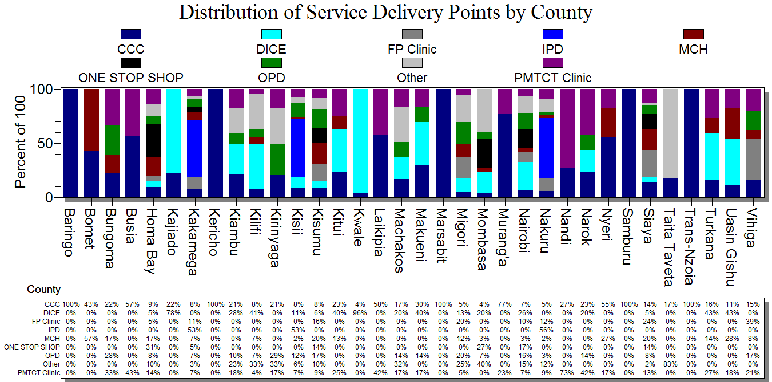

Figure 10: Distribution of service delivery points by county

The table XX illustrates the preferred SDP’s for the 238 facilities that responded. The analysis shows that all of the facilities preferred MCH as an SDP. This was closely followed by CCC’s which were preferred by 192 (84%) of the facilities and OPD’s which were preferred by 155 (68%) facilities. Only five (5) facilities preferred DICE’s as their SDP.

|  |  |  |
| --- | --- | --- |
| **Preferred SDP by Facilities** | **Frequency** | **Percent %** |
| **MCH** | **228** | **100%** |
| **CCC** | **192** | **84%** |
| **OPD** | **155** | **68%** |
| **PMTCT Clinic** | **146** | **64%** |
| **FP Clinic** | **69** | **30%** |
| **IPD** | **29** | **13%** |
| **ONE STOP SHOP** | **8** | **4%** |
| **DICE** | **5** | **2%** |

Table 7: Distribution of preferred service delivery points

# Population receiving PrEP in facilities

The table XX illustrates the population receiving PrEP in the facilities assessed. Out of the 738 facilities that responded, 707 (90.29%) facilities which formed the majority were offering PrEP to discordant couples, 243 (31.03%) facilities were offering PrEP to the general population which comprised of pregnant women, fisher folk, people with recurring STI’s and multiple sex partners with unknown HIV status while 126 (16.09%) facilities where offering to AYGW. People Who Inject Drugs (PWID’s) were receiving PrEP from the least number of facilities 31 (0.4%).

|  |  |  |
| --- | --- | --- |
| **Population** | **No of Facilities** | **Percent** |
| **Discordant Couples** | 707 | 90.3% |
| **General Population** | 256 | 34.7% |
| **FSW - Female Sex Workers** | 163 | 20.8% |
| **Adolescents & young girls & women** | 126 | 16.1% |
| **MSM - Men who have sex with men** | 95 | 12.1% |
| **PWID** | 31 | 4.0 % |

Table 8: Key populations targeted for PrEP

# Laboratory Services

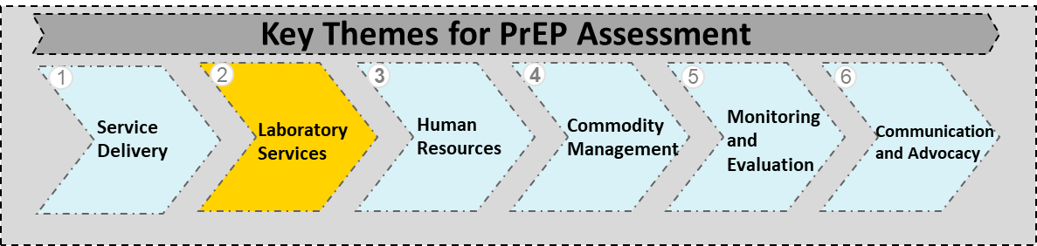This section assessed the accessibility of laboratory services by the facilities, on site or offsite testing and availability of the requisite equipment and reagents. Before PrEP is initiated, a rapid HIV test must be carried out. Baseline creatinine tests are recommended but should not delay the initiation to PrEP while HBsAg and HCV serology tests are to be carried out where available.

The overall analysis in table XX of the laboratory services in the 852 facilities assessed illustrates that majority of the facilities 560 (65.7%), 550 (64.6%) and 636 (74.6%) did not have access to carry out the creatinine, Hep B and Hep C testing respectively with majority of the facilities 695 (81.6%), 644 (75.7%) and 730 (85.7%) carried out the creatinine, Hep B and Hep C laboratory tests off site. Further analysis on the availability of equipment further illustrates that the majority of the facilities 644 (75.6%), 602 (70.7%) and 698 (81.9%) did not have the equipment to conduct the creatinine, Hep B and Hep C tests.

|  |  |  |  |  |
| --- | --- | --- | --- | --- |
|  | | **Creatinine** | **Hep B** | **Hep C** |
| **Access to Testing** | **No** | 65.7% | 64.6% | 74.6% |
| **Yes** | 34.3% | 35.4% | 25.4% |
| **Onsite and Off Site Testing** | **Offsite** | 81.6% | 75.7% | 85.7% |
|  | **On Site** | 18.4% | 24.3% | 14.3% |
| **Availability of Equipment** | **No** | 75.6% | 70.7% | 81.9% |
| **Yes** | 24.6% | 29.3% | 18.1% |

Table 9: Overall access to laboratory testing, availability of equipment and access to on- site and offsite testing

# Creatinine Testing

The baseline creatinine test is recommended as a minimum laboratory evaluation before PrEP is administered. This test is carried out to identify any pre-existing renal dysfunction. If baseline Creatinine Clearance CrCL < 50 ml/min, PrEP is contraindicated. The county analysis of the 852 facilities assessed as illustrated in figure XX indicates the two (2) facilities assessed in Marsabit county had 100% access to this test while the only facility assessed in Samburu and Trans- Nzoia counties had no access to this test. It further indicates that all other counties had a number of their facilities accessing the test to a certain percentage.

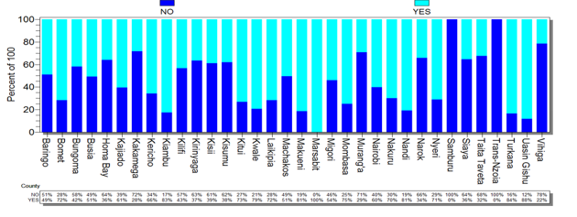

Figure 11: Access to creatinine testing in facilities by county

The by county analysis on the 852 facilities in figure XX on offsite versus onsite testing revealed all the facilities assessed in Marsabit county carried out the testing on site while all facilities in Samburu, Trans Nzoia and Kwale counties were carrying out laboratory testing offsite. This could be an indication that there is a lack of the requisite infrastructure in the various facilities. All other counties had their facilities carrying out the testing either on site or offsite to a certain percentage.

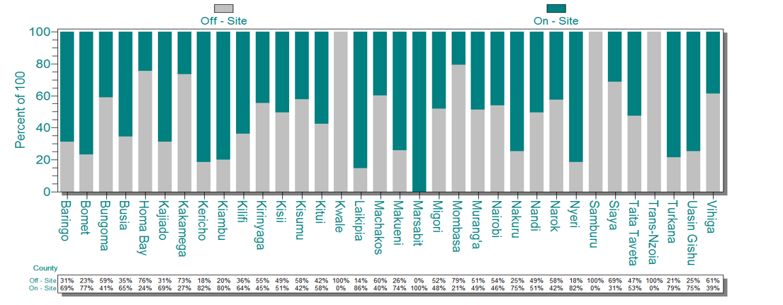

Figure 12: Proportion of facilities that carry out creatinine testing onsite vs offsite

Table XX illustrates that of the 292 facilities that had access to creatinine testing, 135 (46.2%) carried out the creatinine testing offsite.

|  |  |  |
| --- | --- | --- |
| **Creatinine On/Off Site** | **Frequency** | **Percent** |
| **On - Site** | 157 | 53.8% |
| **Off - Site** | 135 | 46.2% |
| **Total** | **292** | **100.0%** |

Table 10: Onsite and offsite testing for facilities with access to creatinine testing

The analysis on availability of equipment to carry out creatinine testing in facilities by county as illustrated in figure XX shows that all the facilities assessed in Marsabit and Trans- Nzoia counties had equipment while none of the facilities assessed in Kwale and Samburu counties had equipment.

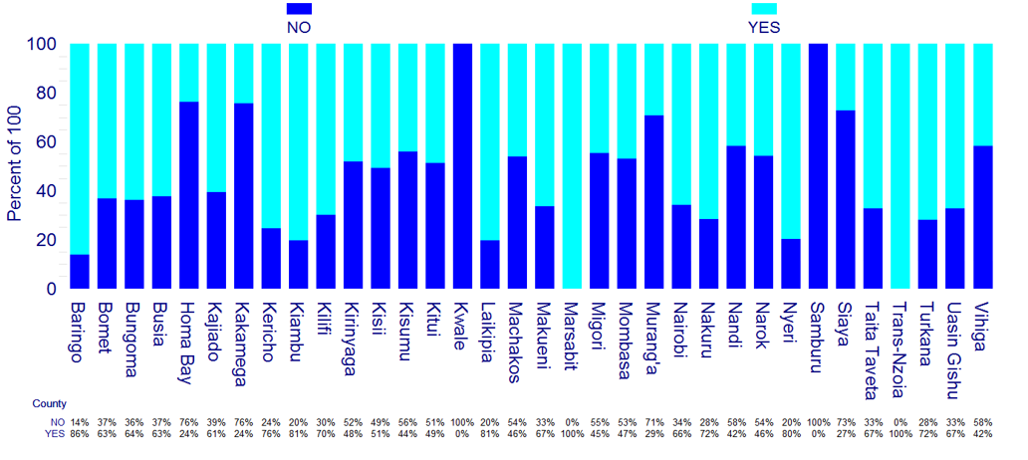

Figure 13: Availability of creatinine testing equipment by county

An analysis on facilities with access to creatinine testing in relation to availability of equipment as illustrated in table XX, revealed that of the 292 facilities only 167 (57.2%) had equipment. This may suggest that those that had access but no equipment were conducting their tests offsite. Figure XX illustrates that all the facilities with access to creatinine testing in seven (7) counties: Baringo, Kericho, Kilifi, Laikipia, Marsabit, Taita Taveta and Vihiga had equipment. Further the facilities assessed in Kwale county that had access did not have any equipment. Of the 560 facilities that had no access to creatinine testing 41 (7.3%) had access to equipment, this could indicate that those with equipment did not have the requisite personnel or reagents to carry out the analysis.

|  |  |  |
| --- | --- | --- |
| **Creatinine Equipment** | **Frequency** | **Percent** |
| **YES** | 167 | 57.2% |
| **NO** | 125 | 42.8% |
| **Total** | **292** | **100.0%** |

Table 11: Access to creatinine testing in relation to equipment availability

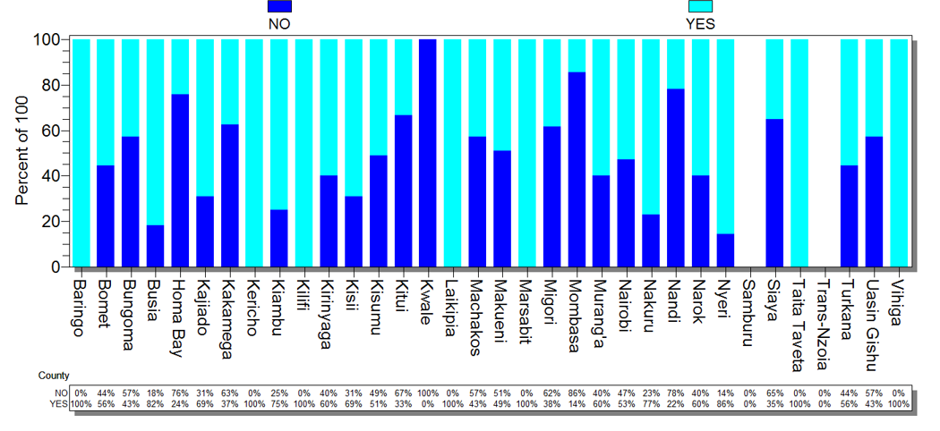

Figure 14: Facilities with access to creatinine testing in relation to availability of equipment

An analysis on availability of creatinine reagents in relation to equipment is illustrated in table XX. Of the176 facilities with creatinine equipment, 172 (97.7%) had creatinine reagents available. The analysis further provides for the reverse whereby of the 676 facilities without creatinine equipment 36 (5.3%) had reagents.

|  |  |  |  |  |  |  |
| --- | --- | --- | --- | --- | --- | --- |
|  | **Facilities with creatinine equipment** | **Frequency** | **Percent** | **Facilities without creatinine equipment** | **Frequency** | **Percent** |
| **Availability of creatinine reagents** | **NO** | 4 | 2.3% | **NO** | 640 | 94.7% |
| **YES** | 172 | 97.7% | **YES** | 36 | 5.3% |
| **Total** | **176** | **100.0%** | **Total** | **676** | **100.0%** |

Table 12: Creatinine equipment vs reagents

# Hepatitis B Testing

The Hepatitis B surface antigen (HBsAg) is advisable and where the results come out negative then the HBV vaccination should be offered. An analysis of the 852 facilities on access to Hepatitis B testing in the facilities by county as illustrated in figure XX indicates that only the facilities assessed in Marsabit and Samburu counties had access to Hepatitis B testing. The analysis also indicates that all facilities assessed in Trans-Nzoia county did not have access to this test. All other counties had their facilities accessing the Hep B test to a certain percentage.

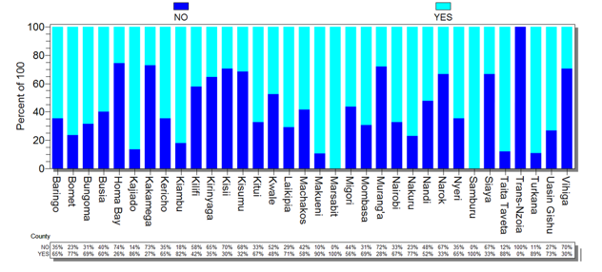

Figure 15: Access to Hepatitis B testing in facilities by county

The by county analysis on the 852 facilities of Hep B on site versus offsite testing indicates that only the facilities assessed in Marsabit and Samburu counties carried out their testing onsite while all facilities assessed in Trans Nzoia county carried out the Hep B testing offsite. All other facilities assessed in the various counties had a mix of both off-site and on-site testing.

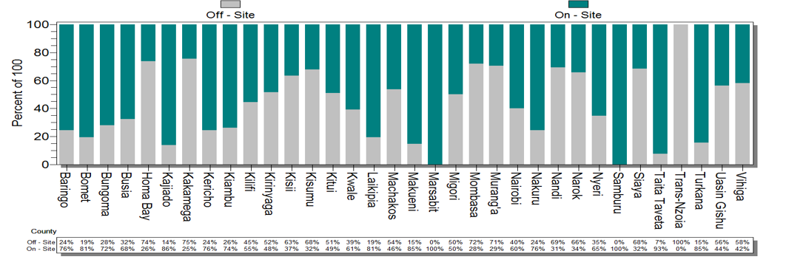

Figure 16: Proportion of facilities that carry out Hepatitis B testing onsite vs offsite

#### The table XX illustrates that of the 302 facilities that had access to Hep B testing, 95 (31.5%) carried out the testing off site.

|  |  |  |
| --- | --- | --- |
| **Hep-B On/Off Site** | **Frequency** | **Percent** |
| **On - Site** | 207 | 68.5% |
| **Off - Site** | 95 | 31.5% |
| **Total** | **302** | **100.0%** |

Table 13: On site vs offsite testing for facilities with access to Hepatitis B testing

The by county analysis on the availability of equipment indicates that all the facilities assessed in Marsabit, Samburu and Trans-Nzoia counties had the equipment. It is important to note that although all the facilities in Trans- Nzoia county had access to the Hepatitis B testing equipment, testing was done off-site.

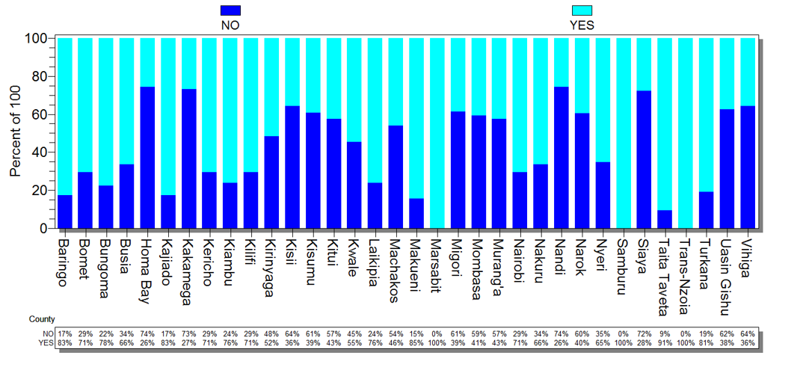

Figure 17: Availability of Hepatitis B testing equipment by county

The majority 203 (67.2%) facilities that had access to Hep B testing had the required equipment (table XX). Figure XX illustrates that all the facilities that had access to Hep B testing in nine (9) counties: Baringo, Kilifi, Kirinyaga, Kwale, Laikipia, Marsabit, Samburu, Taita Taveta and Vihiga counties had testing equipment.

|  |  |  |
| --- | --- | --- |
| **Hep - B Equipment** | **Frequency** | **Percent** |
| **Yes** | 203 | 67.2% |
| **No** | 99 | 32.8% |
|  | 302 | 100.0% |

Table 14: Access to Hep B testing in relation to equipment availability

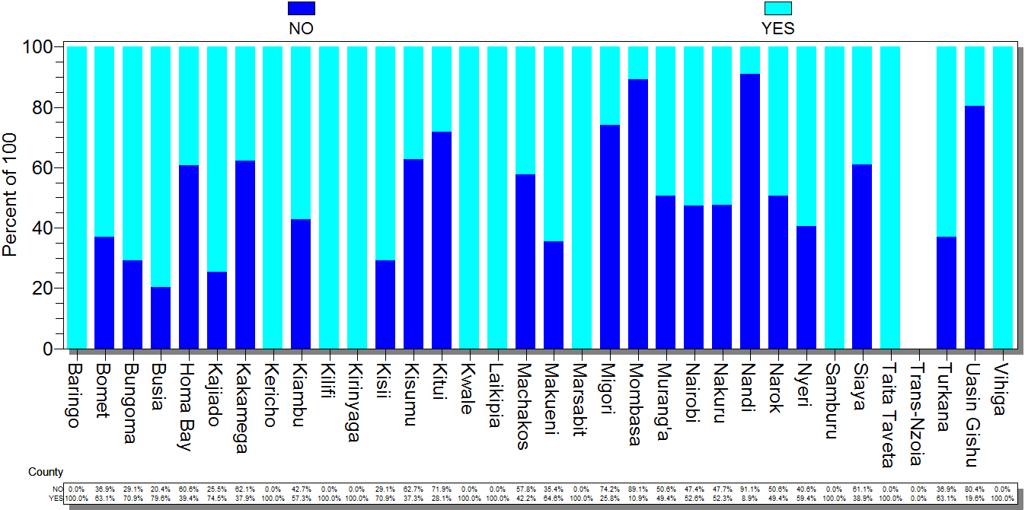

Figure 18: Facilities with access to Hep B testing in relation to availability of equipment

Table XX provides an analysis on the availability of Hep B equipment versus reagents. Of the 250 facilities that had access to Hep B testing equipment, 220 (88.0%) had Hep B reagents, while of the 602 facilities that did not have access to Hep B testing equipment, 2 (0.3%) had the Hep B reagents.

|  |  |  |  |  |  |  |
| --- | --- | --- | --- | --- | --- | --- |
|  | **Facilities with Hep B equipment** | **Frequency** | **Percent** | **Facilities without Hep B equipment** | **Frequency** | **Percent** |
| **Availability of Hep B reagents** | **NO** | 30 | 12.0% | **NO** | 600 | 99.7% |
| **YES** | 220 | 88.0% | **YES** | 2 | 0.3% |
| **Total** | **250** | **100.0%** | **Total** | **602** | **100.0%** |

Table 15: Hep B equipment vs reagents

# Hepatitis C Testing

Hepatitis C antibody (HCV) test is advisable especially for PWID. Where results present as positive, Hepatitis C treatment should be given. An analysis of access to Hep C testing in facilities by county Figure XX shows that of the 852 facilities assessed all the facilities assessed in Narok, Samburu and Trans Nzoia counties did not have access to Hepatitis C testing. However, all the facilities assessed in Marsabit county had access to Hepatitis C testing. All other facilities in the various counties had access to a certain percentage.

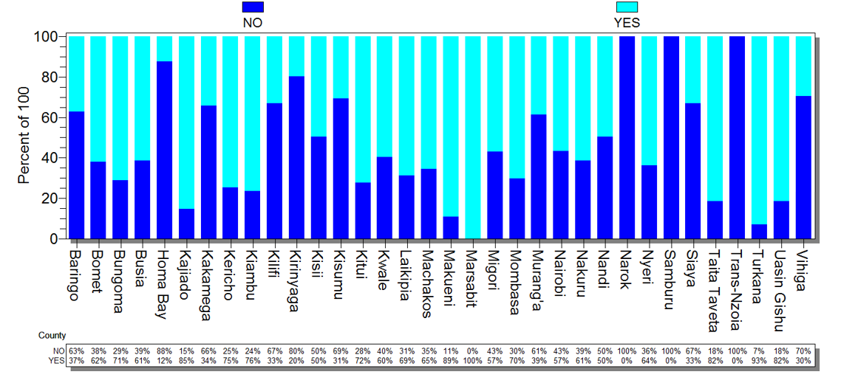

Figure 19: Access to Hepatitis C testing in facilities by county

The county analysis of the 852 facilities in figure XX indicates that facilities assessed in Marsabit county carried out the Hep C testing onsite while all the facilities in five (5) counties: Kwale, Nandi, Narok, Samburu and Trans-Nzoia counties carried out the test offsite. All other counties had facilities carrying out on site and offsite testing to a certain percentage.

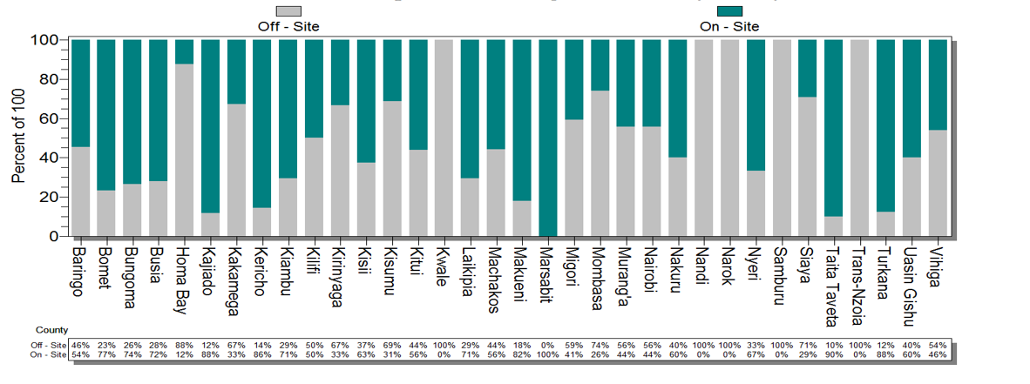

Figure 20: Proportion of facilities that carry out Hepatitis B testing onsite vs offsite

The analysis in table XX indicates that of the 216 facilities that had access to Hep C testing, 94 (43.5%) facilities carried out the testing offsite.

|  |  |  |
| --- | --- | --- |
| **Hep-C On/Off Site** | **Frequency** | **Percent** |
| **On - Site** | 122 | 56.5% |
| **Off - Site** | 94 | 43.5% |
| **Total** | **216** | **100.0%** |

Table 16: On site vs off site testing for Facilities with access to Hepatitis C Testing

The by county assessment in the 852 facilities on availability of Hep C testing equipment in figure XX illustrates that all the facilities in Kwale, Nandi, Samburu and Trans-Nzoia counties did not have the Hepatitis C testing equipment only facilities assessed in Marsabit county had the equipment. All other counties had a percentage of the facilities with Hep C testing equipment.

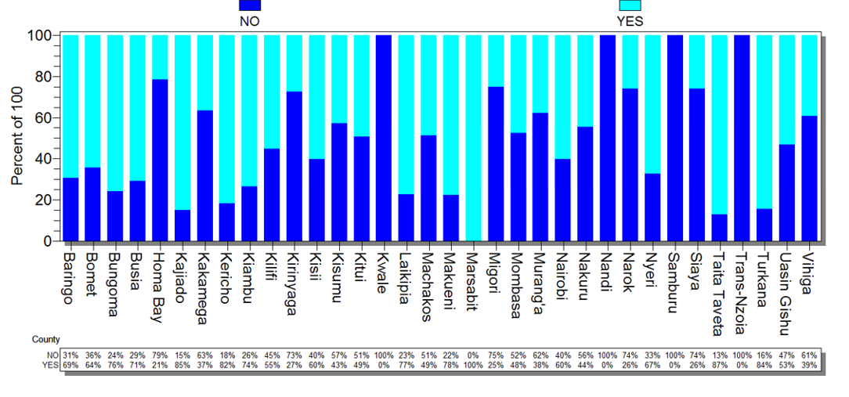

Figure 21: Availability of Hepatitis C testing equipment in facilities by county

The table XX illustrates that of the 216 facilities that had access to Hep C testing, 96 (44.4%) did not have the Hep C testing equipment. The by county analysis in figure XX indicates that facilities that had access to Hep C testing in seven (7) counties: Baringo, Kericho, Kirinyaga, Kilifi, Marsabit, Taita Taveta, Vihiga had no Hep C testing equipment.

|  |  |  |
| --- | --- | --- |
| **Hep - C Equipment** | **Frequency** | **Percent** |
| **Yes** | 120 | 55.6% |
| **No** | 96 | 44.4% |
|  | 216 | 100.0% |

Table 17: Access to Hep C testing versus equipment

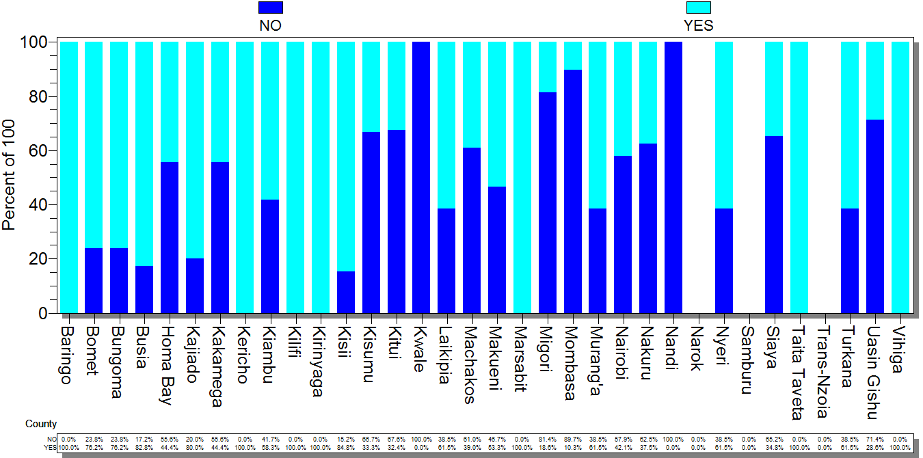

Figure 22: Facilities with access to creatinine testing in relation to availability of equipment

The table XX indicates that of the 154 facilities that had Hep C testing equipment, 19 (12.3%) facilities did not have the reagents while of the 698 facilities that had no Hep C testing equipment, only 1 (0.1%) facility had Hep C reagents.

|  |  |  |  |  |  |  |
| --- | --- | --- | --- | --- | --- | --- |
|  | **Facilities with Hep C equipment** | **Frequency** | **Percent** | **Facilities without Hep C equipment** | **Frequency** | **Percent** |
| **Availability of Hep C reagents** | **NO** | 19 | 12.3% | **NO** | 697 | 99.9% |
| **YES** | 135 | 87.7% | **YES** | 1 | 0.1% |
| **Total** | **154** | **100.0%** | **Total** | **698** | **100.0%** |

Table 18: Availability of Hep C equipment versus reagents

# Human Resources

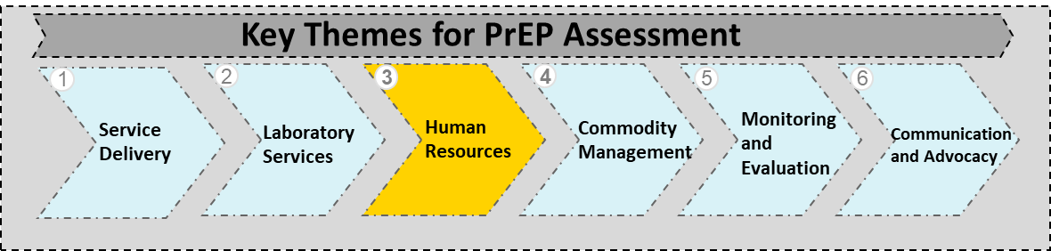

This section assessed the availability of trained personnel offering PrEP service at the facilities. It is recommended that handling, prescription and dispensing of PrEP is done by trained health care professionals as a minimum requirement.

# Proportion of facilities with trained personnel

From the assessment it was noted that of the 852 facilities, 485 (56.9%) facilities had personnel trained on PrEP using two to three day NASCOP training curriculum.

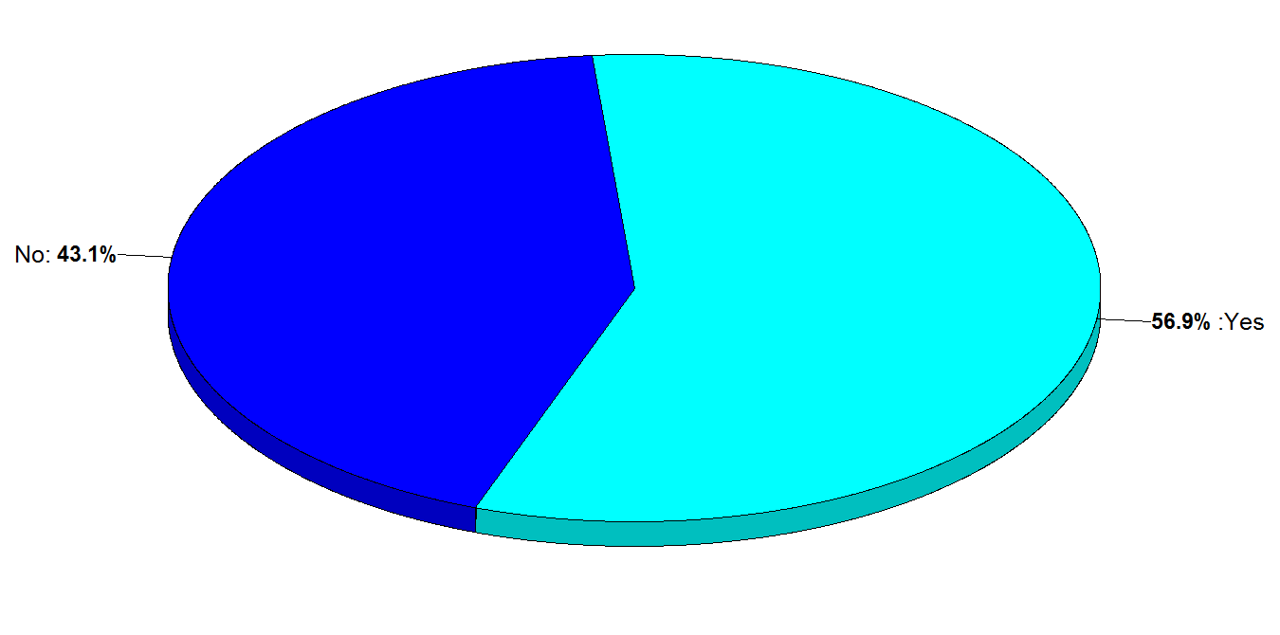

Figure 23: Proportion of trained vs untrained health care workers

The figure XX illustrates the trained personnel by county. Four (4) counties: Kwale, Marsabit, Samburu and Trans Nzoia counties had all of their facilities with personnel trained on PrEP. Majority of the facilities in 10 counties: Bomet, Kajiado, Kirinyaga, Laikipia, Migori, Nakuru, Nandi, Turkana, Uasin Gishu and Vihiga counties did not have trained personnel.

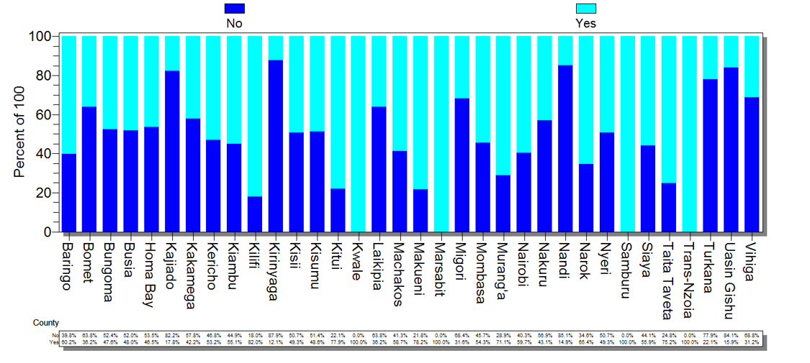

Figure 24: Distribution of trained personnel in facilities by county

# Trained personnel by facility and county

Of the 485 facilities that responded, majority of the facilities 376 (77.5%) had between 1-3 personnel trained while the least 40 (8.2%) facilities had more than six (6) personnel trained on PrEP.

|  |  |  |
| --- | --- | --- |
| **HCW Trained** | **Frequency** | **Percent** |
| **1-3** | 376 | 77.5% |
| **3-6** | 69 | 14.2% |
| **>6** | 40 | 8.2% |
| **Total** | **485** | **100.0%** |

Table 19: Health Care Workers trained for 1-3, 3-6 and >6

The distribution of the number of trained personnel in facilities by county is illustrated in figure XX of which 10 counties: Baringo, Bungoma, Kajiado, Kirinyaga, Kwale, Samburu, Taita Taveta, Trans Nzoia, Uasin Gishu and Vihiga counties had all facilities with between 1 and 3 personnel trained on PrEP. All assessed facilities in Marsabit county had between 3 and 6 personnel trained on PrEP.

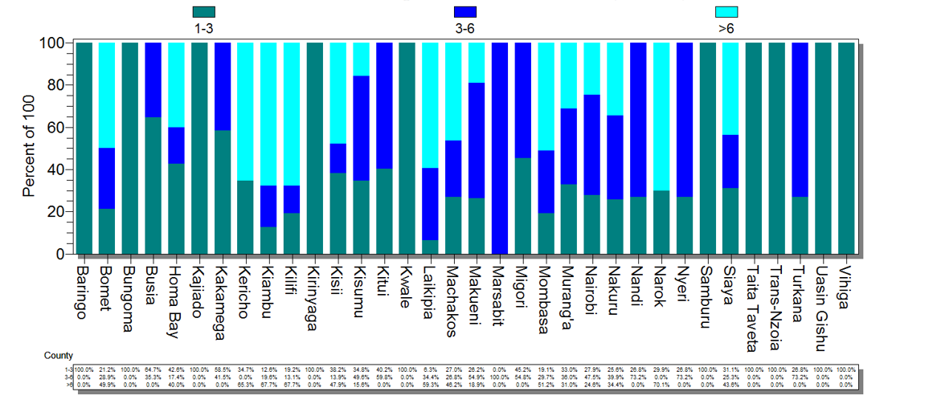

Figure 25: Distribution of trained personnel by numbers in facilities by county

# Type of training

An analysis of the various types of training personnel in facilities have received (table XX) indicates that of the 522 facilities that responded, 333 (63.8%) of the facilities had personnel who underwent the NASCOP PrEP training while 119 (22.8%) of the facilities had their personnel trained on PrEP by partners while 70 (13.4%) had personnel trained by NASCOP and partners.

|  |  |  |
| --- | --- | --- |
| **Type of Training** | **Frequency** | **Percent** |
| **NASCOP PrEP training** | 333 | 63.8% |
| **Partner training package** | 119 | 22.8% |
| **NASCOP PrEP training and**  **Partner training package** | 70 | 13.4% |

Table 20: Type of training received

# Distribution of cadres trained on PrEP

The distribution of the cadres trained on PrEP is as outlined in figure XX of the 997 health care workers trained in the facilities, the majority 396 (39.7%) were Clinical Officers, 273 (27.4%) were Nurses while 113 (11.3%) were HTS providers. The cadre with the least trained personnel were Medical Officers 16 (1.6%). Other cadres that were trained on PrEP included Health Records Information Officers, Laboratory Technologists and Social Workers.

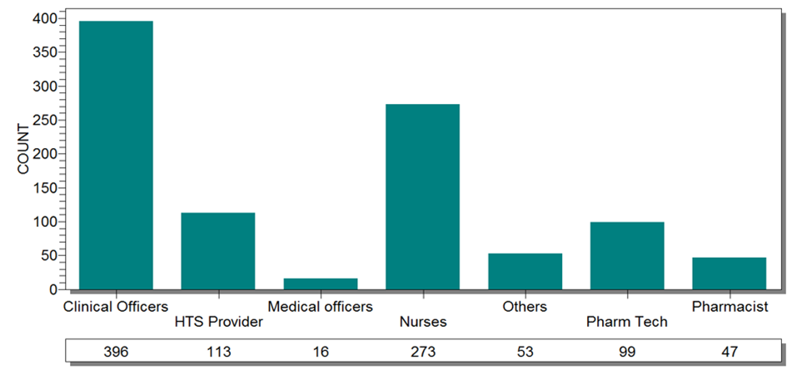

Figure 26: Distribution of cadre trained on PrEP

# 3.4.5 Location of trained personnel

# 3.4.6 Proportion of each cadre offering PrEP

# 3.4.7 Trained personnel vs those offering PrEP

# Commodity Management

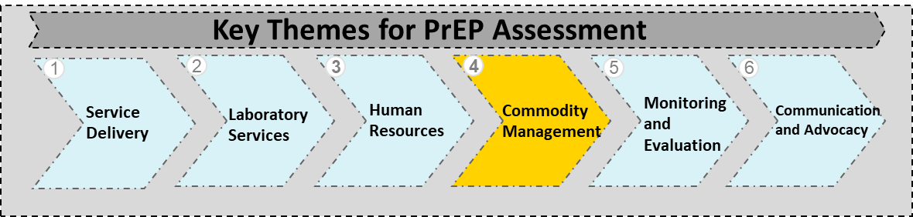

This section assessed the supply, management, access and availability of PrEP from the national stores to the facilities. It established the sources of PrEP, the various dispensing points, cadres dispensing PrEP as well software used for dispensing in the facilities. Regular commodity assessment provides information on HIV commodity requirements, financial commitments and quantification.

# PrEP facilities offering ART

# Source of ARV’s in facilities

The figure XX indicates the sources of ARV’s for the 810 respondent facilities. A majority of the facilities 432 (53.3%) are satellite facilities that access ARV’s from central sites. Facilities that source their ARVs directly from KEMSA were 378 (46.7%). These comprised of central sites 90 (11.1%) and stand-alone 288 (35.6%).

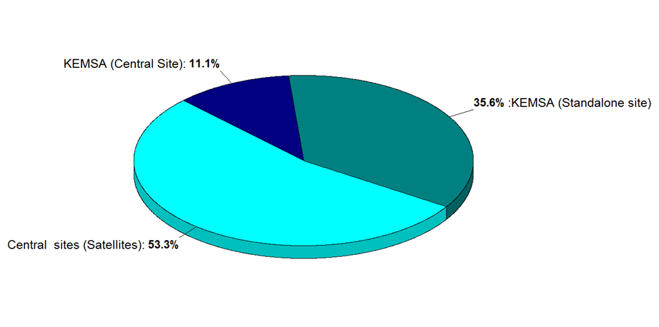

Figure 27: Source of ARVs in facilities assessed

The by county analysis for the sources of ARVs as illustrated in figure XX shows that majority of the facilities in 10 counties: Baringo, Kericho, Kiambu, Kwale, Machakos, Nakuru, Nyeri, Turkana, Trans Nzoia and Uasin Gishu were central sites. Further, majority of the facilities in 11 counties: Bomet, Busia, Kirinyaga, Kitui, Laikipia, Makueni, Marsabit, Migori, Mombasa, Narok and Samburu counties were stand alone. Majority of the facilities in seven (7) counties: Homabay, Kakamega, Kisii, Kisumu, Siaya, Taita Taveta and Vihiga were satellite facilities.

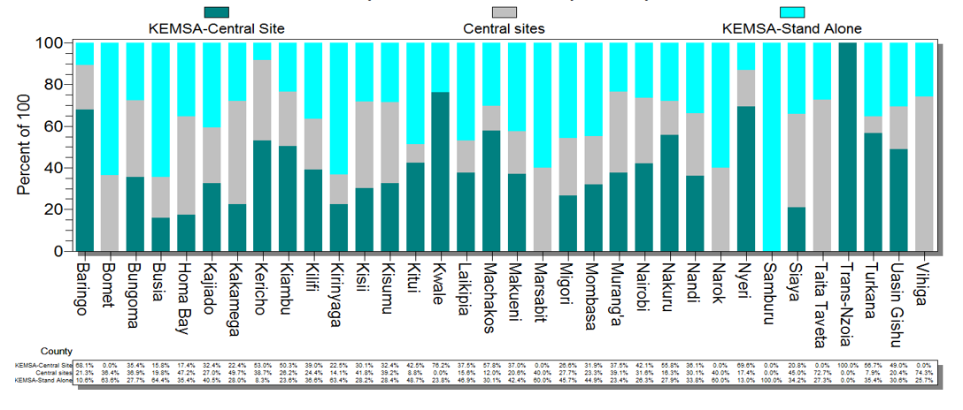

Figure 28: Facility source of ARVs by county

# Dispensing points for PrEP

It is recommended that PrEP is dispensed against a prescription by a qualified health worker. An analysis of the PrEP dispensing points at the 852 facilities assessed established that there a total eight (8) key dispensing points with a frequency of 939 (table XX). Majority of the facilities were dispensing PrEP through CCCs which were 634 (67.5%) while there was only one 1 (0.1%) IPD PrEP dispensing point. Pharmacies, safe spaces, outreaches, key population sites and youth friendly services were the other areas in which PrEP was dispensed.

|  |  |  |
| --- | --- | --- |
| **Where PrEP is dispensed** | **Frequency** | **Percent** |
| **CCC** | 634 | 67.5% |
| **OPD** | 77 | 8.2% |
| **Others** | 74 | 7.9% |
| **PMTCT Clinic** | 58 | 6.2% |
| **MCH** | 47 | 5.0% |
| **DICE** | 19 | 2.0% |
| **ONE STOP SHOP(Everything in one room)** | 19 | 2.0% |
| **FP** | 10 | 1.1% |
| **IPD** | 1 | 0.1% |
| **Total** | **939** | **100.0%** |

Table 21: PrEP dispensing points for facilities assessed

The by county analysis of PrEP dispensing points as shown in figure XX indicates that majority of the counties had CCC’s as the PrEP dispensing point with exception of four (4) counties: Baringo, Kwale, Marsabit and Trans Nzoia. Samburu and Uasin Gishu counties had all facilities assessed dispensing PrEP through CCC’s.

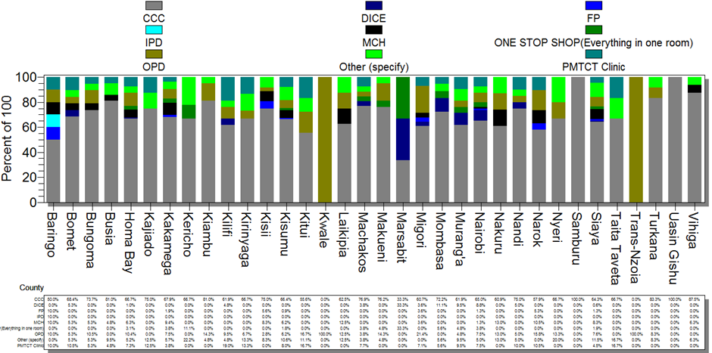

Figure 29: PrEP dispensing points in facilities by county

# Proportion of stock levels in facilities

PrEP stock levels in the facilities is as analysed in table XX. Of the 833 respondent facilities, the majority 338 (40.6%) facilities had stocks for between 0 to 2 years. This was followed by 114 (13.7%) with stocks of between 3 to 6 months and 103 (12.4%) with stocks of between 6 to 15 months. It is worth noting that 84 (10.1%) of the facilities had PrEP clients but no stock while 27 (3.2%) had no clients and no stocks.

|  |  |  |
| --- | --- | --- |
| **Months of stocks** | **Frequency** | **Percent** |
| **0-2** | 338 | 40.6% |
| **2-3** | 75 | 9.0% |
| **3-6** | 114 | 13.7% |
| **6-15** | 103 | 12.4% |
| **Above 15 MOS** | 51 | 6.1% |
| **Had client no stock** | 84 | 10.1% |
| **No clients with stocks** | 25 | 3.0% |
| **No clients/No Stocks** | 27 | 3.2% |
| **With Stock but no Client** | 16 | 1.9% |
| **Total** | **833** | **100.0%** |

Table 22: Stock levels in facilities

# PrEP regimens dispensed

The recommended ARV regimen for use as PrEP is TDF/FTC (300 mg/200 mg) as FDC once daily. Table XX illustrates that of the 814 respondent facilities, the majority 714 (87.7%) were dispensing the preferred regimen while 92 (11.3%) of the facilities were dispensing TDF/3TC while 8 (1%) were dispensing TDF which are the recommended alternatives.

|  |  |  |
| --- | --- | --- |
| **PrEP product being dispensed** | **Frequency** | **Percent** |
| **TDF/FTC** | 714 | 87.7% |
| **TDF/3TC** | 92 | 11.3% |
| **TDF** | 8 | 1.0% |
| **Total** | **814** | **100.0%** |

Table 23: PrEP regimens dispensed at facilities assessed

The by county analysis of the PrEP regimens dispensed at the facilities assessed is as outlined in figure XX. Of the 814 facilities that responded, Siaya county had majority of its facilities offering the preferred PrEP regimen. This was closely followed by Homabay, Kisumu and Nairobi counties. Only a few of the facilities in six (6) counties: Bomet, Homabay, Kitui, Machakos, Nakuru and Uasin Gishu counties were dispensing TDF.

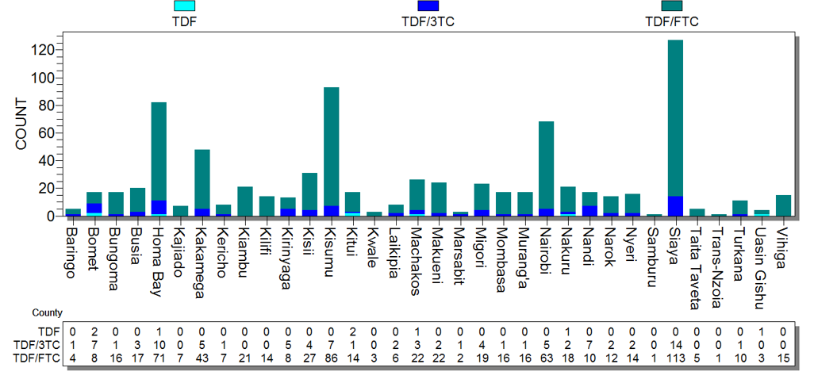

Figure 30: PrEP regimen in facilities by county

# Cadres dispensing PrEP

The figure XX indicates that proportion of the various cadres dispensing PrEP at the facilities of the 470 respondent facilities, 671 personnel were dispensing PrEP, Clinical Officers were the majority at 247 (36.8%). This was followed by Pharmaceutical Technologists 194 (28.9%) and Nurses 157 (23.4%). It is also worth noting that out of all the facilities, there was found to be only one (1) Medical Officer dispensing PrEP.

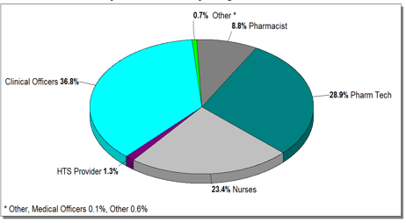

Figure 31: Cadres dispensing PrEP at the facilities

The by county analysis in figure XX outlines the distribution of cadres dispensing PrEP in the facilities. All the facilities in Kirinyaga and Trans Nzoia counties had Pharmaceutical Technologists dispensing PrEP. All counties had a percentage of Clinical Officers dispensing PrEP with exception of seven (7) counties: Bomet, Kirinyaga, Kajiado, Samburu, Trans Nzoia, Turkana and Uasin Gishu counties. There was only one (1) Medical Officer dispensing PrEP in Machakos County.

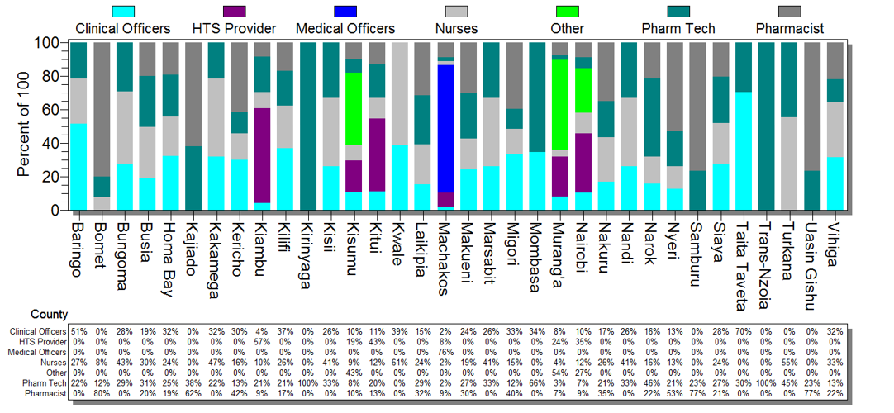

Figure 32: Distribution of cadres dispensing PrEP in facilities by county

# Type of PrEP dispensing software

The pharmaceutical management dispensing softwares that were in use at the facilities to dispense PrEP are outlined in table xx. It is worth noting that of the 819 respondent facilities, the majority 390 (47.6%) did not have the requisite software instead using manual registers. 157 (19.2%) of the facilities used Web ADT while 122 (14.9%) used IQ Care to dispense prepare. The least used tool was EDDIT which was in 32 (3.9%) of the facilities.

|  |  |  |
| --- | --- | --- |
| **Software in use** | **Frequency** | **Percent** |
| **Others** | 390 | 47.6% |
| **Web ADT** | 157 | 19.2% |
| **IQ Care** | 122 | 14.9% |
| **Kenya EMR** | 79 | 9.6% |
| **Access ADT** | 39 | 4.8% |
| **EDDIT** | 32 | 3.9% |
| **Total** | **819** | **100.0%** |

Table 24: PrEP dispensing software used

The by county analysis of the distribution of PrEP dispensing software in facilities is as shown in figure XX of which all the counties with exception of Trans Nzoia and Samburu counties had a number of their facilities which did not have access to the various softwares but instead used manual registers.

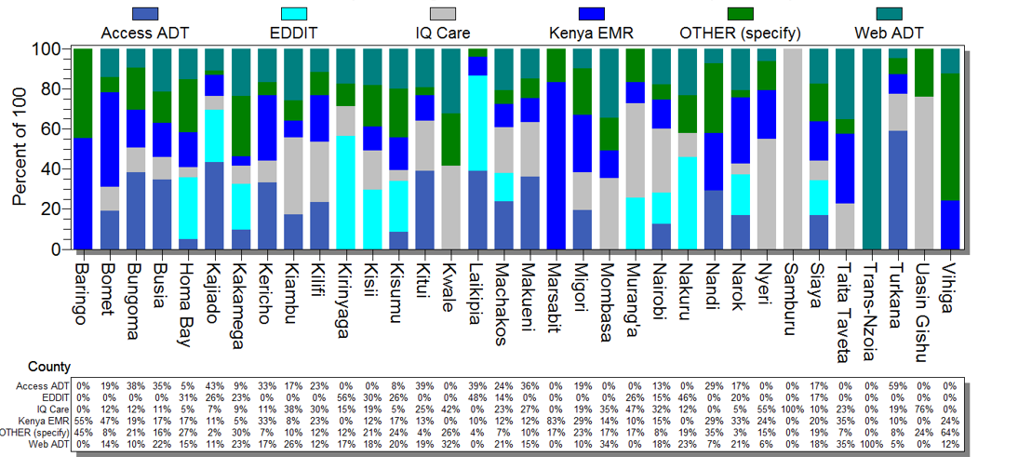

Figure 33: PrEP dispensing software in facilities by county

# Proportion of dispensing staff trained on various trainings

# Monitoring and Evaluation

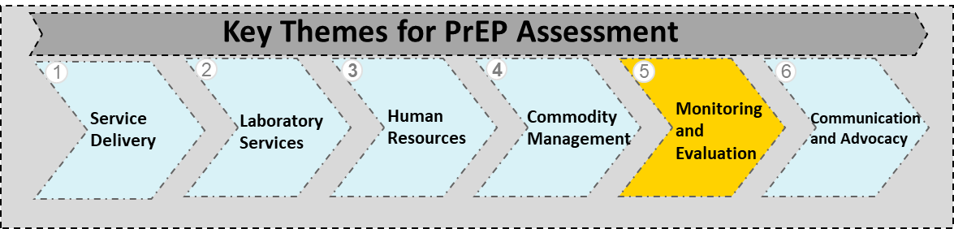This section assessed the availability of essential tools during service delivery, reporting for PrEP services at health facilities, clients on PrEP and active clients by sub-populations. Documentation of PrEP uptake must include the completion of the M & E tools for purposes of effective tracking, reporting of progress to the District Health Information Systems (DHIS) and effective record keeping.

The table XX outlines overall availability of the M & E tools identified in the 852 facilities. Pharmacovigilance tools were available in 698 (81.9%) facilities, followed by clinical encounter forms in 576 (67.6%) facilities. The least available M & E tool was the PrEP register 369 (43.3%) facilities.

|  |  |  |  |  |
| --- | --- | --- | --- | --- |
| **M & E Tools** | **Available Frequency** | **(Percent)** | **Unavailable Frequency** | **(Percent)** |
| **Pharmacovigilance Reporting Tool** | 698 | 81.9% | 154 | 18.1% |
| **Clinical Encounter Form** | 576 | 67.6% | 276 | 32.4% |
| **ARV LMIS Tool** | 502 | 58.9% | 350 | 41.1% |
| **Rapid Assessment Tool** | 429 | 50.4% | 423 | 49.6% |
| **PrEP Summary Reporting Tool** | 370 | 43.4% | 482 | 56.6% |
| **PrEP Register** | 369 | 43.3% | 483 | 56.7% |

Table 25: Overall availability of PrEP M & E tools

# LMIS tools

The LMIS tool is used to collect data for commodities to aid in proper planning of activities for the health facilities. Figure XXXX shows that only two (2) counties Marsabit and Samburu Counties had all facilities assessed that reported to have no LMIS tools while four (4) counties: Baringo, Kericho, Kwale and Trans Nzoia Counties had all facilities with the LMIS tools. Further, majority of the facilities assessed in 10 counties: Bungoma, Busia, Kajiado, Kakamega, Kilifi, Kirinyaga, Kisii, Kisumu, Makueni, Siaya counties reported unavailability of this tool.

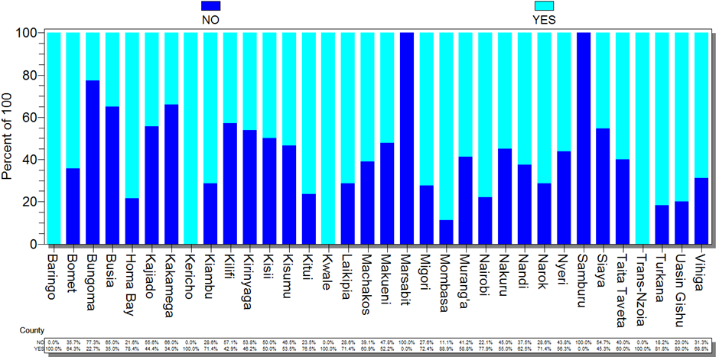

Figure 34: Availability of LMIS tools in facilities by county

# Clinical encounter forms

The PrEP clinical encounter form is a tool that is used during clinical visits by a clinician to document patient bio-data and clinical information. All facilities assessed in Marsabit county indicated they lacked the forms while facilities assessed in Samburu county reported availability of the form as outlined in figure XX. It is also important to note that majority of the facilities in six (6)counties: Baringo, Bungoma, Kakamega, Laikipia, Taita Taveta and Turkana counties reported unavailability of these forms.

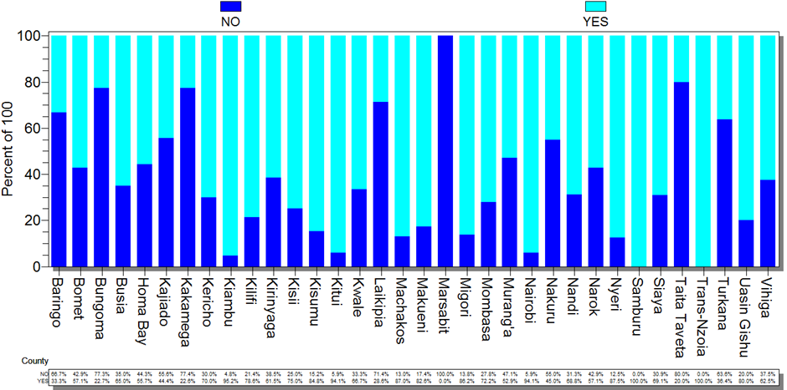

Figure 35: Availability of clinical encounter form in facilities by county

# Pharmacovigilance tools

Pharmacovigilance tools are used to check the ability of facilities to document and report on ADR’s experienced by PrEP users and quality of medicines. The forms that were assessed were ADR form (yellow form) and poor-quality medicine (pink form). The by county analysis indicates that all facilities assessed in Marsabit and Samburu had no pharmacovigilance tools while all the facilities in the five (5) counties: Baringo, Kericho, Nandi, Nyeri and Trans- Nzoia had the pharmacovigilance reporting tools as illustrated in figure XXX

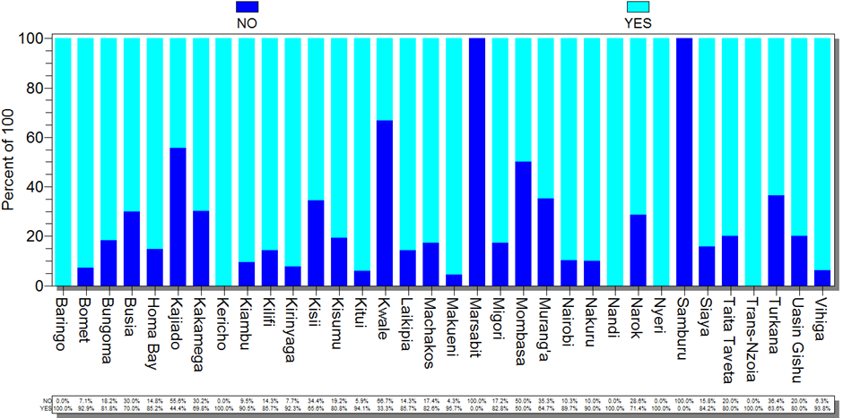

Figure 36: Availability of pharmacovigilance tools in facilities by county

# PrEP register

This is a longitudinal register where all PrEP users should be recorded. The county analysis in figure xxx illustrates that all the facilities assessed in eight (8) counties: Baringo, Kericho, Kwale, Migori, Nakuru, Samburu, Taita Taveta, and Uasin Gishu counties reported a complete lack of the PrEP register in any of the facilities with only facilities assessed in Trans Nzoia county reporting availability of the PrEP register. All other counties reported to have a few facilities with the PrEP register.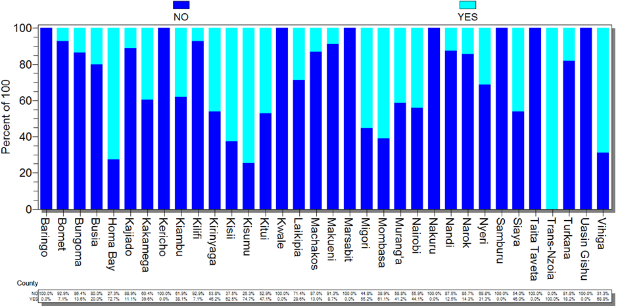

Figure 37: Availability of PrEP register in facilities by county

# Rapid assessment screening tool

The tool is used to stratify client risk of HIV acquisition and help the health worker to determine the PrEP use eligibility for an individual. The county analysis in figure XX illustrates that facilities assessed in four (4) counties: Baringo, Kericho, Marsabit and Nakuru did not have the rapid assessment screening tool while all facilities assessed in Samburu recorded availability of this tool.

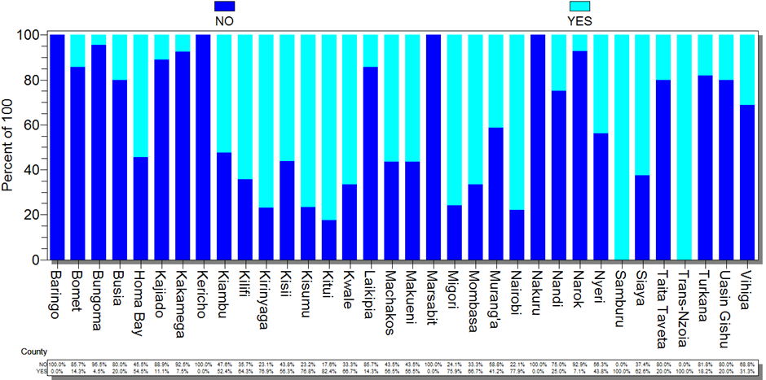

# PrEP summary tool

The PrEP summary tool is used to aggregate client PrEP data for a month. The analysis in Figure XX indicates that all facilities assessed in Baringo, Kericho, Marsabit and Taita Taveta counties lacked the PrEP summary tools with only facilities assessed in Trans-Nzoia county reporting availability of the tool. Further majority of the facilities assessed in 11 counties: Bomet, Bungoma, Busia, Kajiado, Kakamega, Laikipia, Nakuru, Nandi, Narok, Turkana and Uasin Gishu counties did not have the PrEP summary tool.

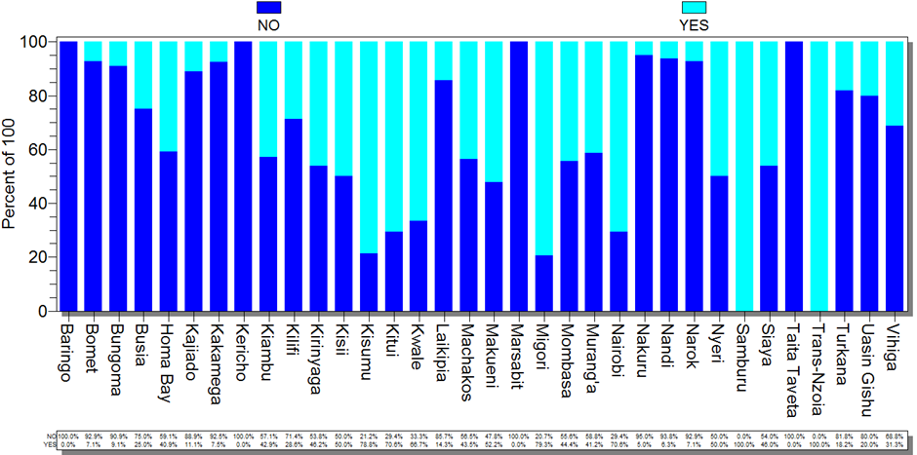

Figure 38: Availability of PrEP summary tool in facilities by county

# Clients ever started on PrEP

The total number Clients ever started on PrEP in the 852 facilities assessed were 24,896 clients. Nairobi county reported the highest numbers of 8,971 followed by Kisumu county 5,807. Marsabit county had the least number of clients ever started on PrEP as the end of February 2018 as illustrated in the figure XX.

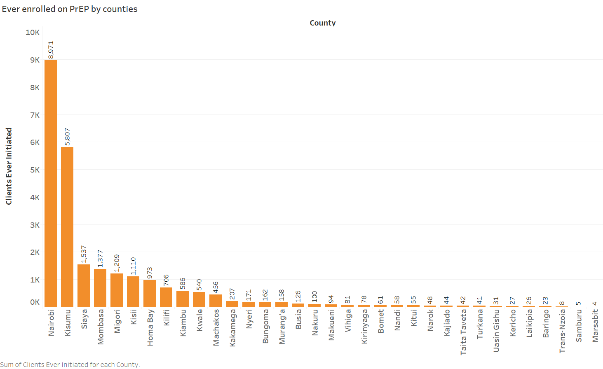

Figure 39: Clients started and active on PrEP

# Clients currently on PrEP and active

As at February 2018, the total number of Clients on PrEP in comparison to those who had ever started on PrEP had significantly reduced in majority of the counties n= XXXX. This is indicative that PrEP is not a lifelong drug and is only used to prevent HIV for those at a high on-going risk of infection. Case in point is Nairobi county whereby those started as previously mentioned were 8,971 and those currently on PrEP were 5,445. The same trend was seen in Kisumu county with the numbers decreasing from 5,807 to 4,580 respectively. In some counties however, the numbers remained stagnant. These were Marsabit, Samburu, Trans-Nzoia and Kitui counties

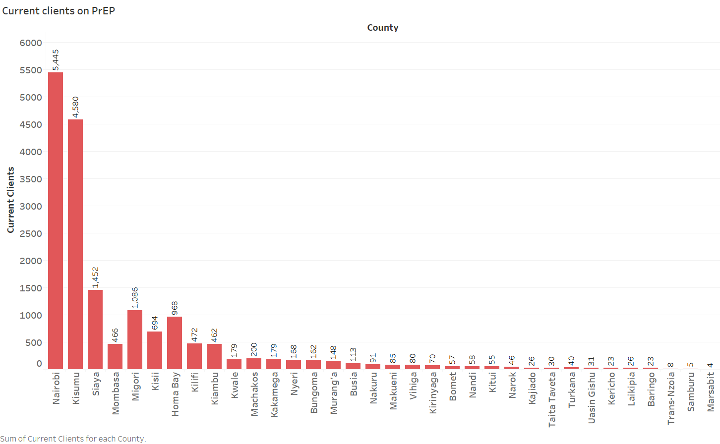

Figure 40: Clients currently on PrEP

Broken down by age bracket and gender and by target population

# Proportion of facilities using EMR’s

The use of EMR’s aids in making clinical data readily available in the facilities. As illustrated in table XX, the availability of EMR for client records of the 786 facilities that responded, 607 (77.2%) of the facilities did not have the EMR’s for client records.

|  |  |  |
| --- | --- | --- |
| **Availability of EMR’s for client records** | **Frequency** | **Percent** |
| **No** | 607 | 77.2% |
| **Yes** | 179 | 22.8% |
| **Total** | **786** | **100.0%** |

Table 26: Availability of EMR’s for client records

# Communication and Advocacy

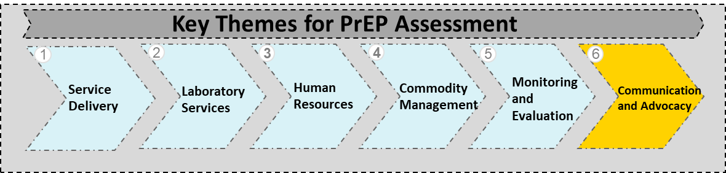

This section intended to appraise the measures that have been put in place to inform, educate and disseminate PrEP related communication thereby increasing PrEP demand and scaling up its use within communities surrounding the facilities being assessed.

An overall analysis on the availability of communication and advocacy tools indicates that of the 852 facilities assessed, Information, Education and Communication (IEC) materials were available in 309 (36.3%), activities on PrEP education materials were available in 432 (50.7%) facilities while demand creation was available in 409 (48%) of facilities assessed.

|  |  |  |  |  |
| --- | --- | --- | --- | --- |
| **Communication and Advocacy Mechanisms** | **Available Frequency** | **(Percent)** | **Unavailable Frequency** | **(Percent)** |
| **Activities on PrEP Education** | 432 | 50.7% | 420 | 49.3% |
| **PrEP Demand Creation** | 409 | 48.0% | 443 | 52.0% |
| **IEC Materials** | 309 | 36.3% | 543 | 63.7% |
| **Data Availability** |  |  |  |  |

Table 27: Availability of communication and advocacy mechanisms

# Availability of IEC materials

An analysis on the availability of IEC materials by county as indicated in figure XX indicates all facilities assessed in Samburu and Kwale counties reported availability of the IEC materials. All the facilities in six (6) counties: Bomet, Laikipia, Marsabit, Narok, Trans-Nzoia and Uasin Gishu counties lacked IEC materials. Lack of the IEC materials would mean that a majority of the facilities did not have the requisite tools to transfer knowledge to the intended target population

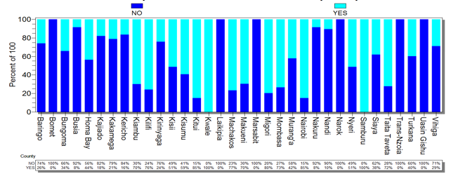

Figure 41: Availability of PrEP IEC materials in facilities by county

# Availability of activities about PrEP education

The county analysis in figure XX, indicates that all the facilities in Baringo, Marsabit and Samburu counties did not have the PrEP education activities while all facilities assessed in Trans-Nzoia County reported to have these activities.

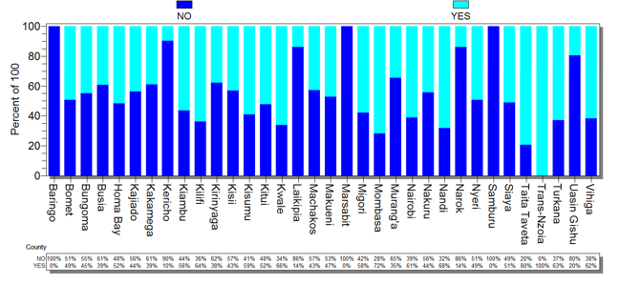

Figure 42: Availability of activities about PrEP education in facilities by county

# Availability of demand creation

Demand creation mechanisms are intended to educate the target population on PrEP. The figure XX indicates that all the facilities assessed in Baringo, Marsabit, Samburu and Trans-Nzoia did not have demand creation mechanisms. The analysis further indicates that no county had 100% of its facilities with demand creation activities.

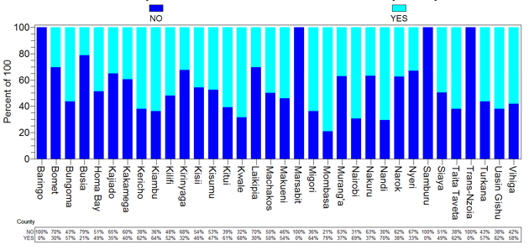

Figure 43: Availability of demand creation activities in facilities by county

# Availability of data

# PATIENT SPECIFIC INFORMATION FROM FILES ASSESSED

The assessment also involved analyzing PrEP client files at the facilities visited. The total number of files assessed were 2,138 which contained client specific information. The outcome was grouped into the categories outlined below: -

# Gender and age distribution

Figure XX indicates that of the 2,138 files assessed, overall there were more female PrEP clients 1,227 (57.4%) than male PrEP clients 910 (42.6%). The age bracket of 24- 30 years had the majority of PrEP clients 658 (30.8%) while the 0 – 15 years age bracket had the least number of clients on PrEP with only 35 (1.6%) of the total files assessed.

There were more female PrEP clients than male in the age bracket of 15 – 19 years 82 (79.6%), 19 – 24 years 266 (70.4%), 24 – 30 years 402 (61.1%) and 30 – 40 years 331 (55.6%).

However there were more male PrEP clients than female in the age brackets of 0-15 years 22 (62.9%), 40 – 50 years 131 (58.2%), 50 – 60 years 62 (64.6%) and above 60 years 42 (89.4%).

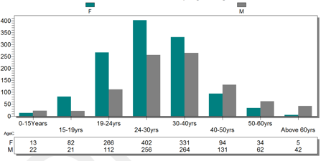

Figure 44: Age distribution of PrEP patients from patient files assessed

# Current status – LTFU, Active, Unknown, Not Documented

The current status analysis as illustrated in table XXX,of the 2,138 files assessed, majority of the patients 1,765 (82.6%) were active PrEP clients. 4 (0.2%) of the total client files assessed were of sero-converted patients which were the least. LTFU PrEP clients were 82 (3.8%) while PrEP clients who defaulted were 76 (3.6%).

|  |  |  |
| --- | --- | --- |
| **Status** | **Frequency** | **Percent** |
| **Active** | 1765 | 82.6% |
| **Self-discontinued** | 141 | 6.6% |
| **LTFU** | 82 | 3.8% |
| **Defaulted** | 76 | 3.6% |
| **Clinician-discontinued** | 40 | 1.9% |
| **Other** | 30 | 1.4% |
| **Sero-converted** | 4 | 0.2% |
| **Total** | **2138** | **100.0%** |

Table 29: Current status of PrEP patients

# Duration on PrEP

The trend analysis in figure XX illustrates that the number of clients on PrEP and the duration on PrEP is inversely proportional. Of the 2,138 client records, the number of clients who have been on PrEP in the short term are the majority. The highest number of clients 731 (34.2%) have been on PrEP for 2 months followed by 327 (15.3%) who have been on PrEP for 3 months. It is worth noting that 7 (0.3%) clients have been on PrEP for between 12 months to 24 months and a negligible 2 (0.1%) have been on PrEP for more than 24 months.

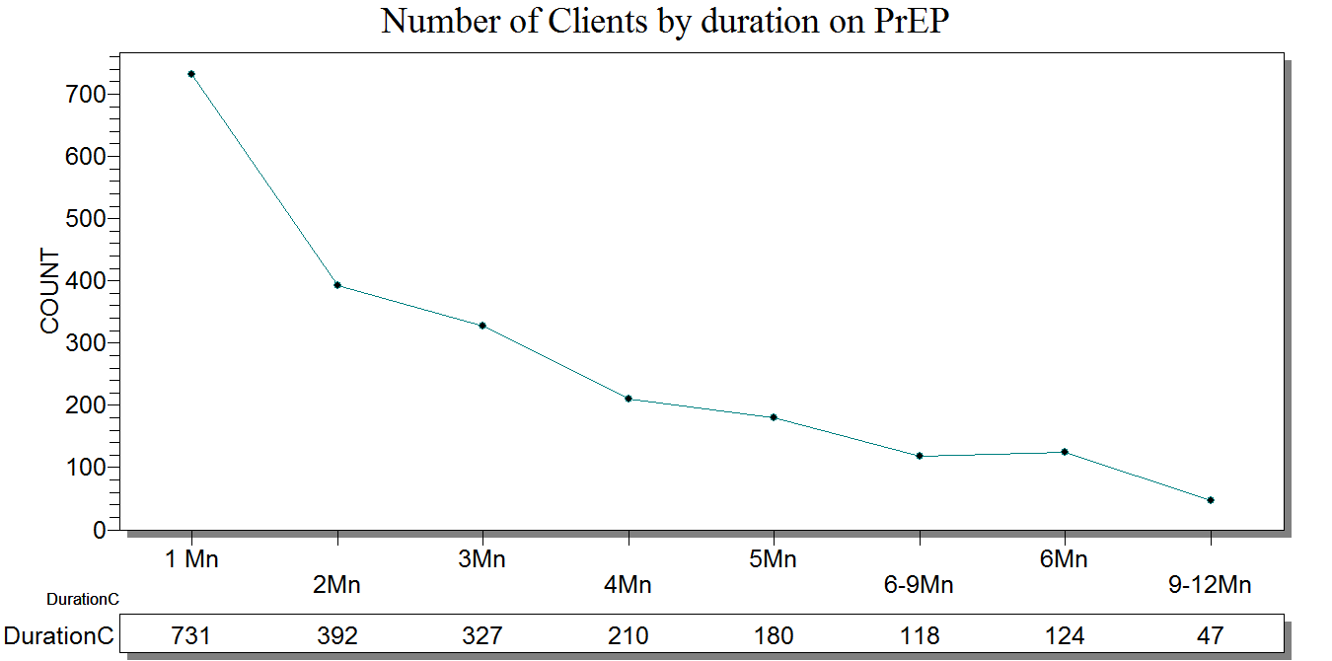

Figure 45: Number of clients by duration on PrEP

# Laboratory tests conducted

The files assessed contained information on creatinine, Hep B and Hep C laboratory tests conducted on the PrEP clients (table XX). Of the 2,138 client records, 1,832 (85.7%) files had no record of creatinine test records, 1,882 (88.0%) files had no Hep B test records while 1,998 (93.5%) had no records of Hep C tests.

|  |  |  |  |  |  |  |
| --- | --- | --- | --- | --- | --- | --- |
|  | **Creatinine Frequency** | **Percent** | **Hep B Frequency** | **Percent** | **Hep C Frequency** | **Percent** |
| **NO** | 1832 | 85.7% | 1882 | 88.0% | 1998 | 93.5% |
| **YES** | 306 | 14.3% | 256 | 12.0% | 140 | 6.5% |
| **Total** | **2138** | **100.0%** | **2138** | **100.0%** | **2138** | **100.0%** |

Table 30: Patient files showing creatinine, Hep B and Hep C testing records

Figure XX further illustrates that all the facilities assessed in Kajiado, Laikipia, Trans-Nzoia and Uasin Gishu had no records of the creatinine test being carried out. Only facilities assessed in Marsabit county had all the files in the facilities indicating that the creatinine test was conducted

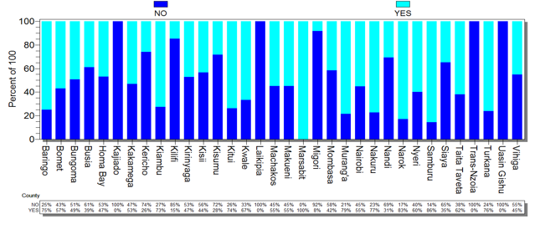

Figure 46: Creatinine testing in the facilities by county

The Hep B test records analysis by county in figure XX indicates that all the facilities in five (5) counties: Baringo, Kwale, Laikipia, Nandi and Trans-Nzoia counties did not have records of Hep B tests having been carried out. No count had all its facilities with 100% records of Hep B test having been conducted.

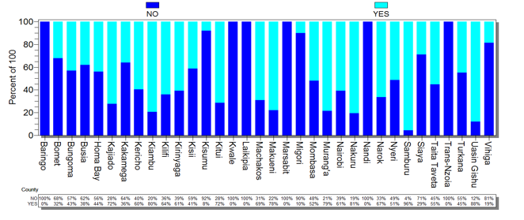

Figure 47: Hepatitis B testing in facilities by county

The by county as illustrated in figure XX for Hep C test records indicate that 14 counties: Baringo, Bomet, Kajiado, Kericho, Kisumu, Kwale, Laikipia, Marsabit, Nandi, Nyeri, Trans- Nzoia, Turkana, Uasin Gishu and Vihiga counties showed that no Hepatitis C test was conducted.

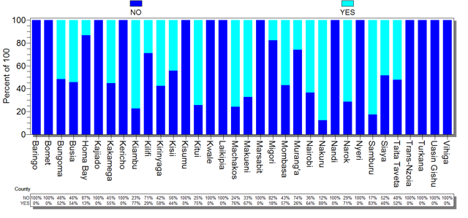

Figure 48: Hepatitis C testing in facilities by county

# Eligibility

The table XX illustrates the proportion of files that had the eligibility of the clients documented. Of the 2,138 patient files assessed, the majority 1,964 (91.9%) had their eligibility to receive PrEP documented.

|  |  |  |
| --- | --- | --- |
| **Eligibility Documented** | **Frequency** | **Percent** |
| **YES** | 1964 | 91.9% |
| **NO** | 174 | 8.1% |
| **Total** | **2138** | **100.0%** |

Table 31: Eligibility recording in client files assessed

# Client follow up mechanism

The various client PrEP follow mechanisms available in the facilities is outlined in table XX, of the 783 facilities that responded, 655 (83.7%) facilities followed up PrEP clients using phone calls. 254 (32.4%) of the facilities generated lists of defaulters while 136 (17.4%) facilities followed up by use of sms. Support groups were the least used follow up mechanism.

|  |  |  |
| --- | --- | --- |
| **Follow up mechanism** | **Frequency** | **Percent** |
| **Follow-up phone calls** | 655 | 83.7% |
| **Generate list of defaulters** | 254 | 32.4% |
| **CHW Training** | 144 | 18.4% |
| **SMS Reminders** | 136 | 17.4% |
| **Other** | 115 | 14.7% |
| **Support Group** | 90 | 11.5% |

Table 32: Client follow up mechanisms in the facilities

# CONCLUSION

This section draws conclusions from the analysis in sections 3 and 4 as well as gaps analysed from facilities. CASCO’s and SCASCO’s feedback received from the various counties. The assessment focused on six (6) themes that is service delivery, laboratory services, human resource, monitoring and evaluation, commodity management and communication and advocacy.

Discussions with the CASCO’s and SCASCO’s revealed that the PrEP implementation and uptake remains relatively low. Although majority of the facilities reported to have implementing partner support and a PrEP focal person, the number of PrEP clients were less than 100 in majority of the counties. Further, it was also established that mapping of key populations targeted to receive PrEP was sub-optimal.

It was noted that there was sub-optimal access to laboratories with majority of the facilities that had access carrying out the testing offsite. Equipment to carry out creatinine, Hepatitis B and Hepatitis C testing in facilities was also lacking in facilities and where there was availability of equipment stock outs of reagents were experienced. Where laboratory services were readily available, clients were not willing to pay for them. This resulted in lack of laboratory follow up services due to the cost incurred by the clients

For the personnel offering PrEP in facilities it was noted that of the 852 facilities assessed, only half of the facilities had between 1 - 3 personnel trained on PrEP with majority using the NASCOP documented curriculum. However, majority of the personnel trained were staff in the CCC’s.

For PrEP commodities it was noted that while some facilities reported to have experienced stock outs, other facilities reported to have stock but no clients. Further, a majority of the facilities reported to have stock for between 0 – 2 months with a few facilities reporting to have over 15 months of stock.

The assessment further assessed availability of essential M&E tools during service delivery, Pharmacovigilance tools were found to be the most available tool while PrEP register was the least available tool identified in the 852 facilities. However the use of manual registers was rampant in many of the facilities as PrEP dispensing softwares were not in use in many facilities.

It was noted that there was minimal creation of awareness with regards to PrEP in communities surrounding the facilities as communication and advocacy tools in majority of the facilities were lacking key among them IEC materials.

From the 2,138 patient files assessed, analysed and documented in section 4 of this report it was established that there were more male PrEP clients than female clients in the facilities. Majority of the clients were in the age group of between 24 – 30 years while the least number of PrEP clients were between 0 – 15 years. Creatinine, Hepatitis B and Hepatitis C tests were not carried out prior to administering PrEP in majority of the files assessed.

An overall analysis of challenges identified in the facilities as outlined in table XX illustrates that of the 822 respondent facilities, a majority of the facilities 720 (87.6%) identified lack of PrEP training as a challenge that was being experienced thereby hindering effective implementation of PrEP. This was closely followed by lack of IEC materials which was identified by 632 (76.9%) facilities while 631 (76.8%) facilities identified access to laboratory services as a challenge. It is worth noting that only 158 (19.2%) of the facilities identified commodities as a challenge.

|  |  |  |
| --- | --- | --- |
| **Gaps** | **Frequency** | **Percent** |
| **Training** | 720 | 87.6% |
| **IEC Materials** | 632 | 76.9% |
| **Access to laboratory services** | 631 | 76.8% |
| **M & E Tools** | 611 | 74.3% |
| **LMIS Tools** | 378 | 46.0% |
| **Personnel** | 371 | 45.1% |
| **Client Follow-up Systems** | 332 | 40.4% |
| **Space** | 285 | 6.8% |
| **Commodities** | 158 | 19.2% |
| **Other** | 52 | 6.3% |

# RECOMMENDATIONS

By understanding the findings from the assessment and the current gaps as informed by the facilities and the counties it is clear that there still remains gaps in PrEP implementation in health facilities in Kenya. This section provides solutions to the existing gaps which is an important step in enhancing and expanding PrEP uptake. The figure XX provides an outline of focus areas for PrEP:-

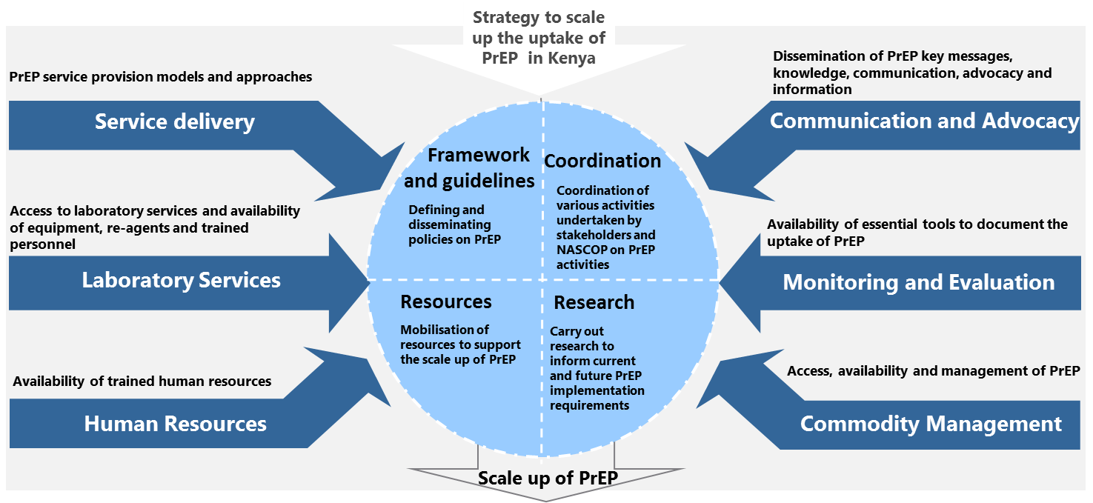

Figure 49: Recommendations to scale up PrEP in Kenya

# Framework and guidelines

In relation to the 6 thematic areas

# Coordination

# Resources

# Research

# ANNEXURES

1. **List of contributors**

# REFERENCES

1. NATIONAL GUIDELINES FOR HIV TESTING AND COUNSELLING
2. MINISTRY OF HEALTH, NATIONAL AIDS & STI CONTROL PROGRAMME. GUIDELINES ON USE OF ANTIRETROVIRAL DRUGS FOR TREATING AND PREVENTING HIV INFECTION IN KENYA 2016. NAIROBI, KENYA: NASCOP, JULY 2016. PRINT.
3. NATIONAL AID’S AND STI CONTROL PROGRAMME WEBSITE: - HTTP://WWW.NASCOP.OR.KE
4. NATIONAL AIDS & STI CONTROL PROGRAMME (NASCOP), MINISTRY OF HEALTH, (2017). FRAMEWORK FOR THE IMPLEMENTATION OF PRE-EXPOSURE PROPHYLAXIS OF HIV IN KENYA, NAIROBI, KENYA: NASCOP.
5. MINISTRY OF HEALTH, NATIONAL AIDS & STI CONTROL PROGRAMME (2018). PRE-EXPOSURE PROPHYLAXIS FOR THE PREVENTION OF HIV INFECTION - A TOOLKIT FOR HEALTH SERVICE PROVIDERS, NAIROBI, KENYA: NASCOP.
6. UNAIDS - [HTTPS://WWW.HIV.GOV/HIV-BASICS/OVERVIEW/DATA-AND-TRENDS/GLOBAL-STATISTICS](https://www.hiv.gov/hiv-basics/overview/data-and-trends/global-statistics)
7. KENYA AIDS RESPONSE REPORT 2016 - HTTP://NACC.OR.KE/WP-CONTENT/UPLOADS/2016/11/KENYA-AIDS-PROGRESS-REPORT_WEB.PDF